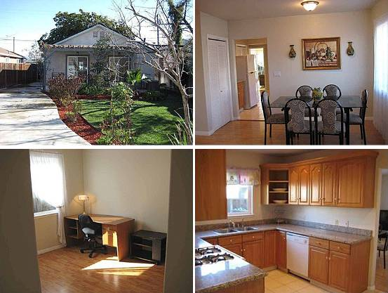
（1）地址：1175 Whitton Ave San Jose CA 95116
房产编号：19711240
价格：$595,000 合 416万人民币
类型：别墅
卧室：3
卫生间：3
面积： 1,700 sq ft 合 158平方米
花园面积：5,227 sq ft
估值：$458,000
2009年财产税：$6,838
建筑年份：2003年
描述：Newly Rebuilt in 2003 3 Bedroom, 3 Bathroom (1700 sf.) home Nice Deep Lot (5227 sf) with New Concrete Driveway Beautiful Open Floor Plan with plenty of light Custom Front Door w/ Leaded Glass &amp; Baldwin Hardware Gourmet Kitchen,Granite Slab,Neutral Tile Floors White Designer Appliances Included in the Sale Inviting Covered Porch w/ Vined Arbor &amp; Columns Stunning Laminate Pergo Floors and Tile throughout New interior six panel Doors with Brass Hardware Designer Touches &amp; Architectural details Inside &amp; Out All Bathrooms feature Marble floors &amp; Marble surround Recessed, Spot, and Accent Lighting Throughout Stylish Master Bedroom w/ soothing colors &amp.

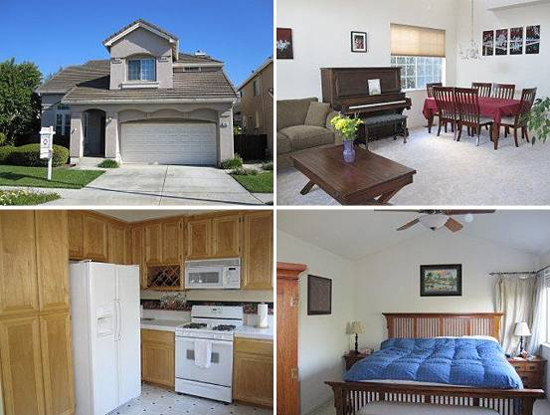
（2）地址：492 S 21st St San Jose CA 95116
房产编号：19714062
价格：$565,000 合 395万人民币
类型：别墅
卧室：4
卫生间：3
面积：1,781 sq ft 合 166平方米
花园面积：4,550 sq ft
估值：$489,500
2002年售价：$501,500
2009年财产税：$7,104
建筑年份：1997年
描述：Light & bright Brookwood home! Move in condition! Central AC*dual pane windows*high ceilings*2" blinds & duettes*separate Fam Rm w/built in cabinets & shelves*fireplace*pro landscaped yard*auto sprinklers*water softener & filter*fridge*No HOA! walk to park: tennis/softball/picnic/play/dog park/softball/more! 4th Bedroom is a custom office with built-in desks, cabinets, glass door!

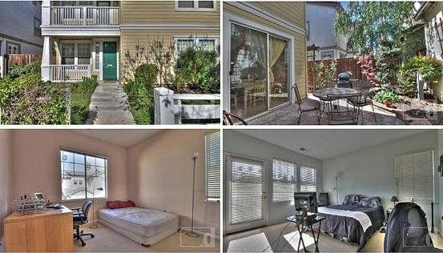
（3）地址：50 S 16th St San Jose CA 95112
房产编号：19710839
价格：$599,950 合 420万人民币
类型：别墅
卧室：3
卫生间：3
面积：1,408 sq ft 合 131平方米
花园面积：2800 sq ft
估值：$474,000
2009年财产税：$5,159
建筑年份：1998年
描述：Rare opportunity to find a newer built home in classic Naglee Park. Old world charm of yesterday combined with all of the new amenities of today. Open floor plan with soaring ceilings, walking distance to town and San Jose State.
.

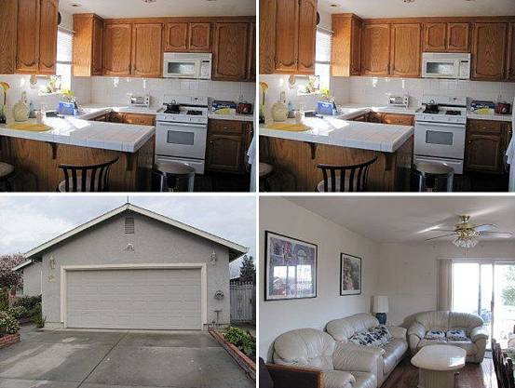
（4）地址：270 Grand Ave San Jose CA 95126
房产编号：19576362
价格：$600,000合 420万人民币
类型：别墅
卧室：4
卫生间：2
面积：1,712 sq ft 合159 平方米
花园面积：6,210 sq ft
估值：$559,500
2002年售价：$495,000
2009年财产税：$6,020
建筑年份：1999年
描述：
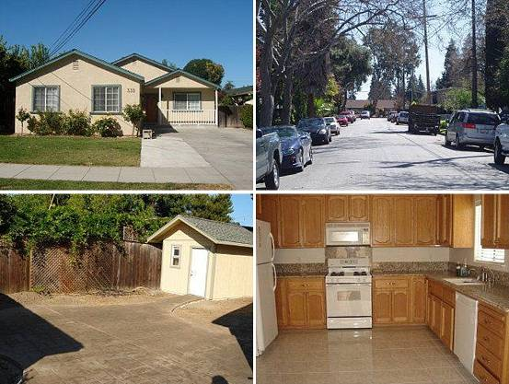
（5）地址：332 S 18th St San Jose CA 95116
房产编号：19712028
价格：$649,000合 454万人民币
类型：别墅
卧室：4
卫生间：2
面积：1,722 sq ft 合 160平方米
花园面积：6500 sq ft
估值：$437,000
2005年售价：$665,000
2009年财产税：$6,269
建筑年份：1997年
描述：A WINNER AT 13 YEARS NEW! Upgraded home in charming neighborhood close to Naglee Park Area. Fantastic large kitchen w/oak cabinets nicely finished w/ granite countertops. Spacious at 1750SQFT, great bedroom sizes and layout. Simple patio, landscaping and stamped concrete backyard makes this property inviting. New Shed built like home. See yourself cozying up in front of the fireplace!
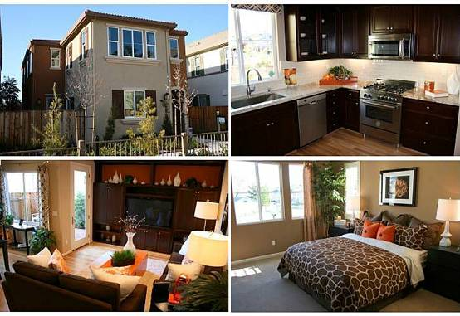
（6）地址：622 N 9th St San Jose CA 95112
房产编号：2132836971
价格：$649,990 合455 万人民币
类型：别墅
卧室：4
卫生间：2.5
面积：1,961 sq ft 合182 平方米
花园面积：2,391 sq ft
建筑年份：2010年
描述：Brand New Single Family Detached homes! Centrally located, easy access to stores, parks and major roadways. Make your home at the Gardens at 9th and T.

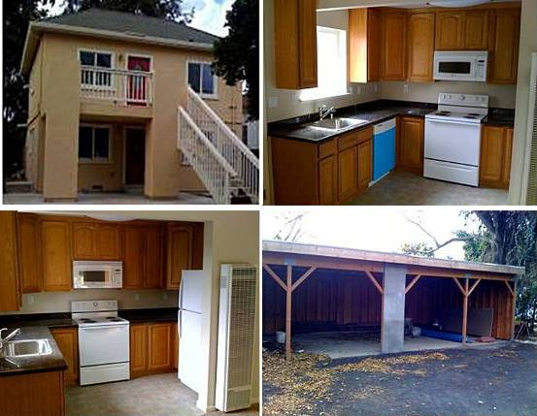
（7）地址：459 Minor Ave San Jose CA 95126
房产编号：19576746
价格：$595,950 合 417万人民币
类型：别墅
卧室：5
卫生间：3
面积：1900 sq ft 合176平方米
花园面积：5227 sq ft
估值：$464,000
2005年售价：$125,000
2009年财产税：$6,899
建筑年份：2009年
描述：Duplex For Sale. Near Downtown San Jose.

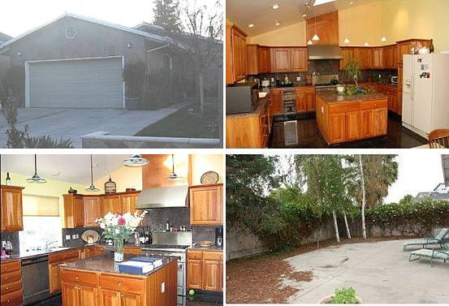
（8）地址：475 Gregory St San Jose CA 95126
房产编号：19576617
价格：$645,000 合451万人民币
类型：别墅
卧室：3
卫生间：2
面积：1200 sq ft 合 111平方米
花园面积:4800 sq ft
估值：$443,000
2006年售价：$650,000
2009年财产税：$6,223
建筑年份：1997年
描述：Modern home close to downtown is in great shape. Stylish slate and stucco exterior. Tile and wood floors inside. Open and bright designer kitchen with high end stainless appliances and granite surfaces is a chief\'s dream. Master suite with a fireplace and walkout patio. Cathedral celings in kitchen and living room. Designer fireplace in living room. Enclosed yard for privacy and safety.

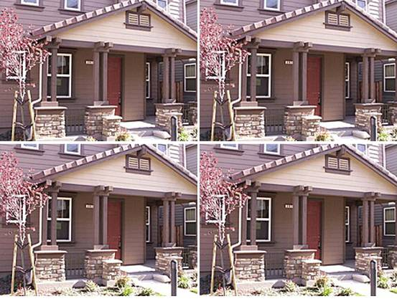
（9）地址：297 Rayos Del Sol Dr San Jose CA 95116
房产编号：79842552
价格：$594,900 合416万人民币
类型：别墅
卧室：5
卫生间：3
面积：2,196 sq ft 合 204平方米
花园面积: 2920 sq ft
估值：$603,500
2009年售价：$486,000
2009年财产税：$9,098
建筑年份：2005年
描述：

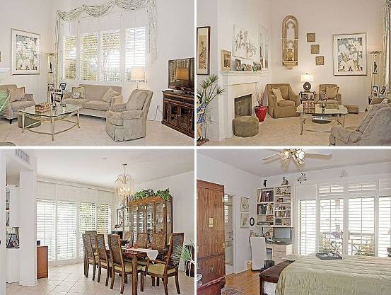
（10）地址：144 S 3rd St San Jose CA 95112
房产编号：2142211918
价格：$579,000 合405万人民币
类型：公寓
卧室：2
卫生间：2.5
面积：1,695 sq ft 合 157平方米
建筑年份：1997年
描述：Gorgeous three-level condo in downtown San Jose for sale. This townhouse-style property is spaciously spread out over three levels. The first level contains the living room, formal dining area, and ktichen. The two master bedroom suites are located separately on the second and third levels for privacy. Each of the bedrooms have their own bathroom and balcony. This unit comes with two side-by-side parking spaces plus an additional separate storage unit.
.

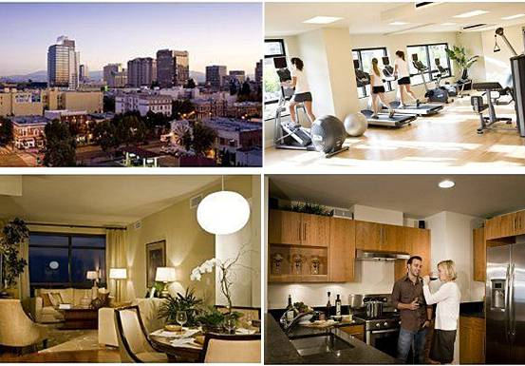
（11）地址：88 E San Fernando St UNIT 1103 San Jose CA 95113
房产编号：89474680
价格：$638,999 合447万人民币
类型：公寓
卧室：2
卫生间：3
面积：1,347 sq ft 合125 平方米
估值：$519,500
2009年财产税：$7,318
建筑年份：2008年
描述：The88 is San Jose's premier view-oriented building and the tallest tower between San Francisco and L.A. Boasting the best location in San Jose, the88 is designed to provide a lifestyle of convenience and low maintenance urban luxury. Available for immediate occupancy, the88 features amenities ranging from a sun-drenched pool, fitness & entertaining room, gracious lobby lounge, hospitality services.

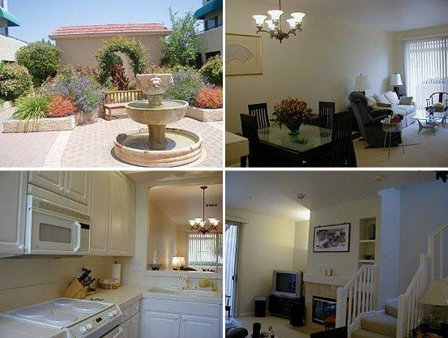
（12）地址：2583 Park Blvd APT W106 Palo Alto CA 94306
房产编号：2132318132
价格：$649,800 合455万人民币
类型：公寓
卧室：2
卫生间：2
面积：1,261 sq ft 合117 平方米
花园面积：871 sq ft
建筑年份：1993年
描述：Immaculate Palo Alto townhome-style condo. Desirable ground floor unit, no one above you for more privacy. Features 2 master suites. Very bright & open floorplan. Patio off the LR w/additional storage. Nice entryway to breakfast nook w/ skylight. Kitchen w/ white cabinetry looking into LR w/fireplace and patio. Easy access to cal-train & California Ave, Shops, restaurants, free shuttle to Stanford.

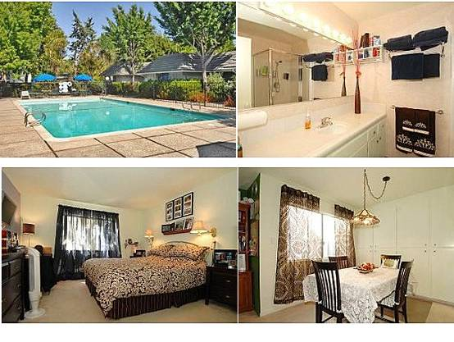

（13）地址：21 Willow Rd APT 8 Menlo Park, CA 94025
房产编号：81014342
价格：$599,000 合 419万人民币
类型：公寓
卧室：2 卫生间：2
面积：1167 sq ft 合 108平米
估值：$616,500
建筑年份：1976年
描述：Price reduced; bring offer then enjoy! Stroll around downtown Palo Alto or Menlo Park and you don't even need to move your car! Many amenities only a short distance away. Relax by the pool, enjoy the lawn/garden area. Lrg private unit with lots of light. Granite counters and stainless appliances in kitchen, new tile floor in master bath, designer paint colors in some rooms.…

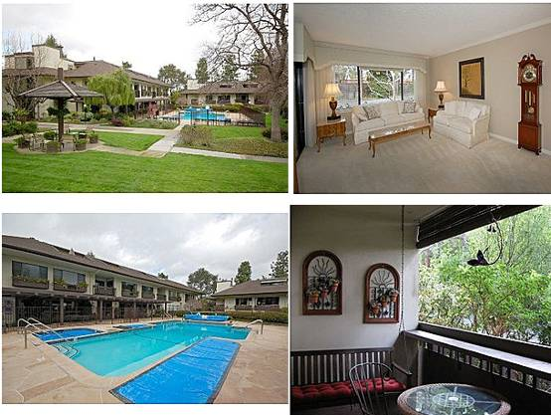

（14）地址：2140 Santa Cruz Ave APT E102 Menlo Park, CA 94025
价格：$525,000合 367万人民币
类型：公寓
卧室：2 卫生间：2
面积：1203 sq ft 合 111平米
估值：$525,500
建筑年份：1978年
描述：This 1203 square foot condo home has 2 bedrooms and 2.0 bathrooms. It is located at 2140 Santa Cruz Ave Menlo Park, California. The nearest schools are Oak Knoll Elementary School, La Entranda Middle School and Palo Alto High School.

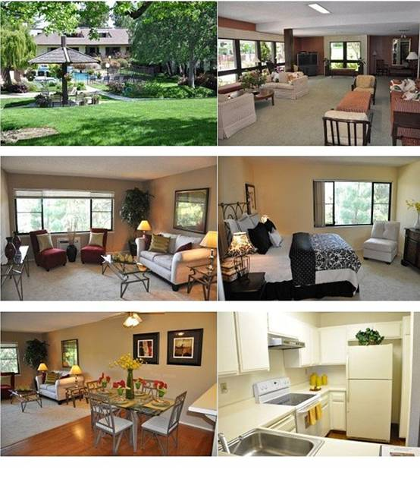（15）地址：2140 Santa Cruz Ave # B-201 Menlo Park, CA 94025
房产编号：81020393
价格：$399,000合 279万人民币
类型：公寓
卧室：2 卫生间：2
面积：960 sq ft 合 89平米
估值：$475,500 建筑年份：1978年
描述：Beautiful 2 bedroom and 2 bath unit in Menlo Commons is ready for you to move in! This unit shows well with newer carpeting, wood flooring, appliances and paint. Enjoy the park-like setting of the common area and all of the association amenities (pool, spa, rec room, and exercise room).

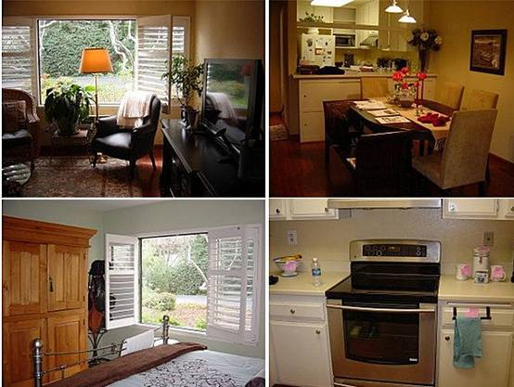

（16）地址：2140 Santa Cruz Ave APT D104 Menlo Park, CA 94025
房产编号：81003446
价格：$469,000合 328万人民币
类型：公寓
卧室：2 卫生间：2
面积：960 sq ft 合89 平米
估值：$476,000
建筑年份：1978年
描述：Ready to move in, quiet end unit, totally redone hardwood flrs, upgraded kitchen, crown moldings, plantation shutters, new paint, acoustic ceilings, air conditioning, updated bathrooms. Unit complex includes pool, spa, rec room, exercise rm, Close to Stanford/shops/transportation. Easy access to 280. 55+…

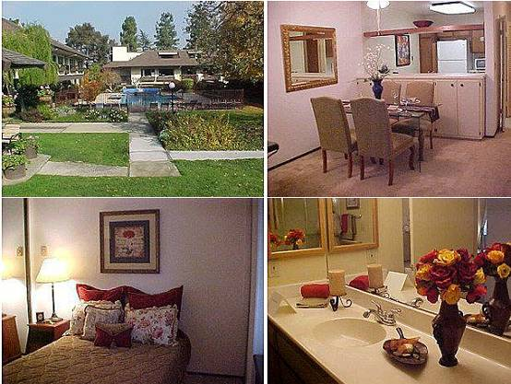

（17）地址：2140 Santa Cruz Ave # B-209 Menlo Park, CA 94025
房产编号：80956046
价格：$329,000合 230万人民币
类型：公寓
卧室：1 卫生间：1
面积：660 q ft 合61 平米
估值：$394,000
建筑年份：1978年
描述：Condo is being leased. Please call Listing Agent with any questions.Brokered And Advertised By: Dolly B. Adams, BrokerListing Agent: Dolly Adams

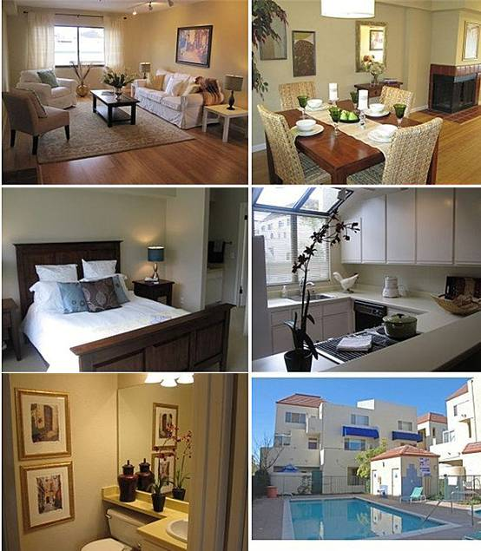

（18）地址：117 S California Ave APT D205 Palo Alto, CA 94306
房产编号：81010169
价格：$585,000合 409万人民币
类型：公寓
卧室：2 卫生间：1.5
面积：1247 q ft 合 115平米
估值：$585,500
建筑年份：1982年
描述：GORGEOUS REMODELED TWO STORY UNIT IN DESIRABLE PA CENTRAL COMPLEX NEXT TO MOLLIE STONES, CALIFORNIA AVE SHOPS AND RESTAURANTS. ELEGANT 2BD/1 1/2BA FEATURES GLEAMING BAMBOO HARDWOOD FLOORS, NEW CARPET IN BEDROOMS, BEAUTIFUL TILE BA, FRESH PAINT, LR W/FIREPLACE, IN-UNIT LAUNDRY, NEAR STANFORD UNIVERSITY, MARGUERTITE SHUTTLE STOPS HERE, CALTRAIN and TOP PALO ALTO SCHOOLS. SECURED BUILDING and PARKING.…

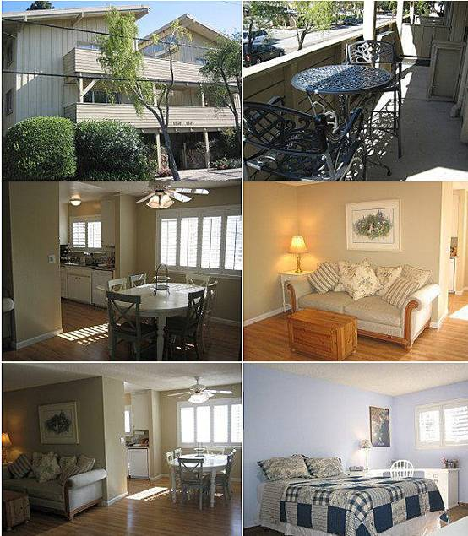

（19）地址：1534 San Antonio Ave Menlo Park, CA 94025
房产编号：81010838
价格：$599,000合 419万人民币
类型：公寓
卧室：3 卫生间：2
面积：704 q ft 合 65平米
建筑年份：1972年
描述：SPACIOUS SECOND FLOOR UNIT IN SECURE BUILDING, WITH 3 BEDROOMS & 2 BATHROOMS (1550 SQ.FT). LARGE LIVING ROOM WITH ACCESS TO BALCONY. UPGRADES INCLUDE: GRANITE COUNTERS, PLANTATION SHUTTERS, LAMINATE FLOORS, REMODELED BATHROOMS, AND MUCH MORE. THERE ARE 2 ASSIGNED PARKING SPACES PLUS A STORAGE CLOSET, AND POOL.

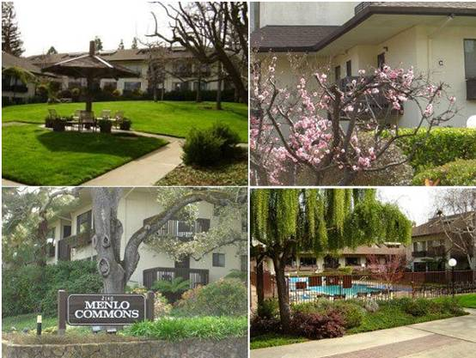

（20）地址：2140 Santa Cruz Ave APT C305 Menlo Park, CA 94025
房产编号：81007157
价格：$329,000合 230万人民币
类型：公寓
卧室：1卫生间：1
面积：710 q ft 合65 平米
估值：$415,500
建筑年份：1972年
描述：Light & Bright Top Floor/Penthouse condo in Menlo Commons. Desirable Southern exposure with Morning Sun & afternoon shade. Move-in condition, freshly painted, staged. Indoor laundry hook-up. Spacious outdoor deck with partial view of mountains. Complex has many features including Pool, Spa, Recreation Romm/Clubhouse. For Adults 55+ years old. Beautiful grounds. Vacant with lockbox. Shows well.Brokered And Advertised By: Cashin CompanyListing Agent: Paul Skrabo…

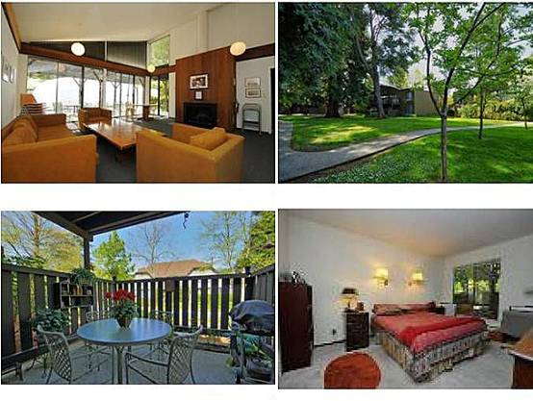

（21）地址：69 Pearce Mitchell Pl Stanford, CA 94305
价格：$348,000合 243万人民币
类型：公寓
卧室：2卫生间：2
面积：925 q ft 合 85平米
估值：$608,000
建筑年份：1975年
描述：Available to Approved Stanford Faculty and Staff Only

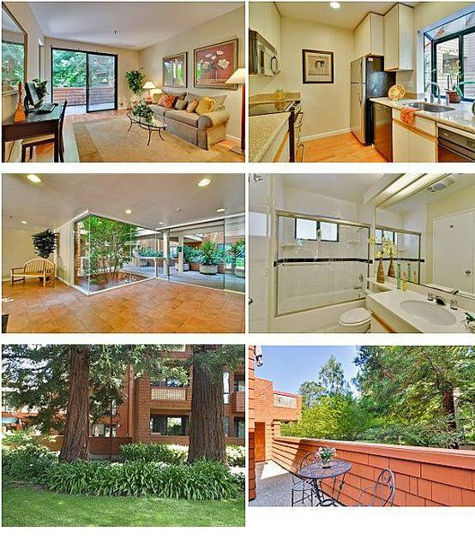

（22）地址：4250 El Camino Real # 129 Palo Alto, CA 94306
房产编号：81021021
价格：$435,000合 304万人民币
类型：公寓
卧室：1 卫生间：1
面积：679 q ft 合 63平米
建筑年份：1983年
描述：Be nurtured by the quiet and comfort of this tranquil setting surrounded by Redwood trees at desirable Palo Alto Redwoods. A hidden oasis conveniently located near all Palo Alto has to offer. Premier location in complex. New and recent updates including gorgeous cherry hardwood floors, new kitchen appliances, updated bathroom tile & new paint.

