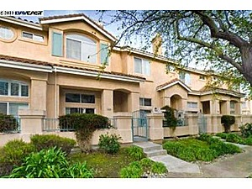
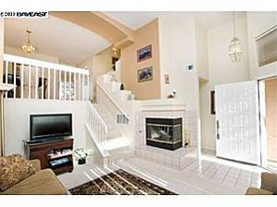
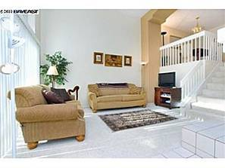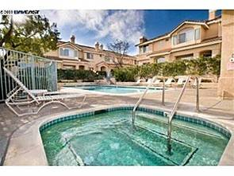
（1）地址：34233 Trampini Cmn # 146 Fremont CA 94555
房产编号：25059468
价格：$535,000 合 374万人民币
类型：公寓
卧室：3
卫生间：2
面积：1,514 sq ft 合 140平米
花园面积：0 sq ft
估值：$491,000
2000年售价：$340,000 2009年财产税：$4,635
建筑年份：1992年
描述：Capriana Beauty! Mediterranean styling accents this upscale Ardenwood TH. Soaring vaulted ceilings, spectacular amenities, awesome commute location: it?s everything you want! These don?t come on the market often-don?t miss it! Open Hs 3/6 & 3/7, 1-4 Full Baths: 2, Partial Baths: 1

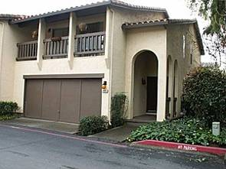
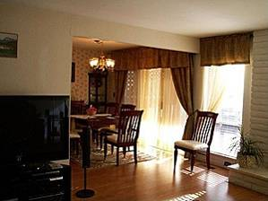
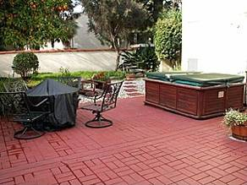
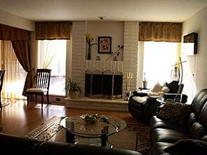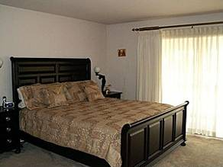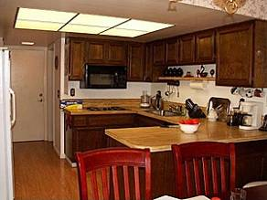
（2）地址：3426 Manchester Cmn Fremont CA 94536
房产编号：2133139491
价格：$410,000 合287万人民币
类型：公寓
卧室：3
卫生间：2
面积：1,634 sq ft 合 151平米
建筑年份：1972年
描述：One of the largest townhome units in Fremont. Centrally located close to the Hub, etc. Gated community, beautiful patio with fruit trees, well maintained, ready to move in.

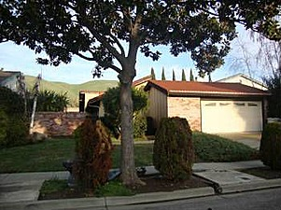
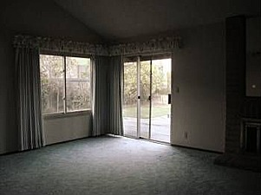
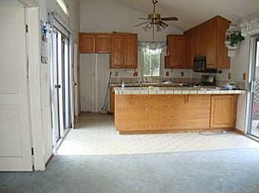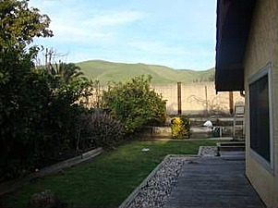
（3）地址：Zacate Fremont CA 94539
房产编号：2133531686
价格：$599,950 合419万人民币
类型：别墅
卧室：3
卫生间：2
面积：1,369 sq ft 合 127平米
花园面积：0 sq ft
建筑年份：1980年
描述：Location, Location, Location, View of the hills from your backyard!

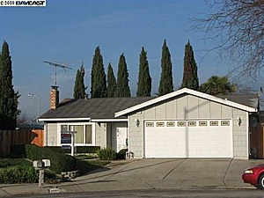
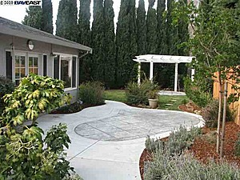
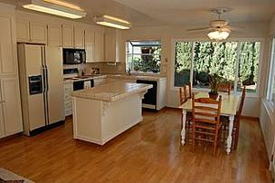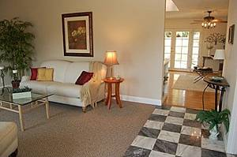

（4）地址：34460 Colville Pl Fremont CA 94555
房产编号：25046153
价格：$524,888 合367万人民币
类型：别墅
卧室：3
卫生间：2
面积：1,300 sq ft 合120 平米
花园面积：6,608 sqft
估值：$496,500
2001年售价：$400,000 2009年财产税：$5,276
建筑年份：1977年
描述：THIS IS AN ELEGANT DOLL HOUSE!! SO MUCH TO OFFER. FRESHLY PAINTED INTERIOR, NEW CARPETING, DUAL PANE WINDOWS, HARDWOOD FLOORS IN KITCHEN/FAMILYROOM.FRENCH DOORS AND WALL OF WINDOWS FROM FAM ROOM TO REAR YD. NEW LANDSCAPING IN REAR. STAMPED CONCRETE. SIDE ACCESS. IT'S A WINNER!!

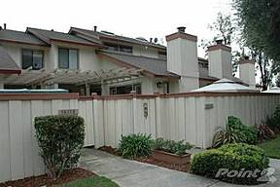
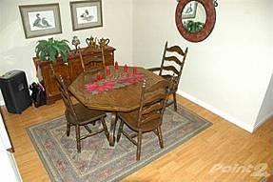
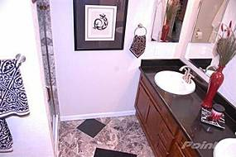
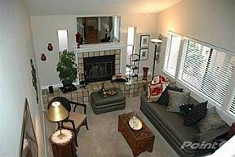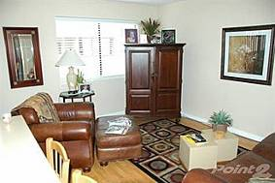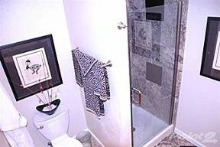
（5）地址：38332 Redwood Ter Fremont CA 94536
房产编号：2134387863
价格：$485,000合339万人民币
类型：别墅
卧室：3
卫生间：2
面积：1,521 sq ft 合 141平米
建筑年份：1987年
描述：Regular Sale--Size matters w/ this Parkmont beauty next to BART. tax recs say 1521 sq ft, but there's an approx 300 sq ft bonus room w elec. closet and heat below. Pergo, kitchen ceiling raised w/ lights inst. 2 balconies, A/C, laundry inside, fireplace & attached 2 car gar. Rooms get lots of light.<br/><br/>Brokered And Advertised By: Tricity Real Estate Brokers<br/>Listing Agent: Jeff Pereyda Fremont CA Realtor
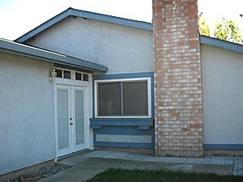
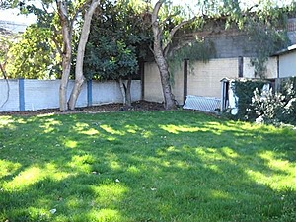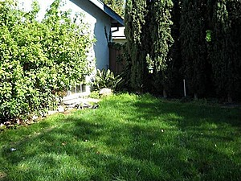

（6）地址：4388 Gordon Pl Fremont CA 94555
房产编号：25051241
价格：$400,000合280万人民币
类型：别墅
卧室：3
卫生间：2
面积：1,180 sq ft 合 109平米
花园面积：8,589 sqft
估值：$431,500
2006年售价：$615,000
2009年财产税：$7,114
建筑年份：1987年
描述：3 bedroom/2bath home is located in desirable neighborhood. One of the largest lots in the neighborhood! Laminate flooring, sun tubes, large eat in kitchen. Patio in large backyard. Cemented side yard.

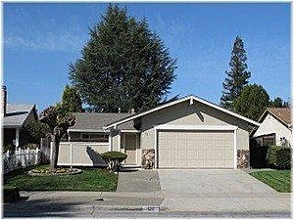
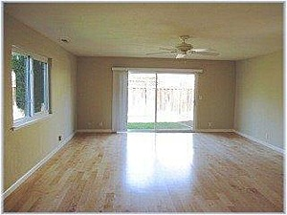
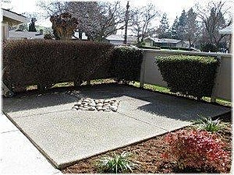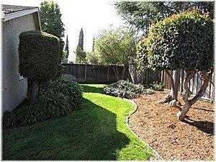
（7）地址：123 Avenida Espana San Jose CA 95139
房产编号：19841021
价格：$599,000合419万人民币
类型：别墅
卧室：3
卫生间：2
面积：1,254 sq ft 合116 平米
花园面积：0 sqft
估值：$445,000
1984年售价：$105,000
2009年财产税：$2,483
建筑年份：1972年
描述：This one is detailed and ready to move in! Remodeled top to bottom & is a must see, New kitchen, New windows, Newer roof, Deluxe bathrooms, Fresh paint inside & out, Huge (24x16) master suite/family room, Newer central air & heating system, New inside doors, Manicured yards front & rear, Private front court yard with views of the hills, Nice side patio area off the kitchen, Lots more must see. Information provided by seller and others has not been independently verified by CENTURY 21 Alpha.

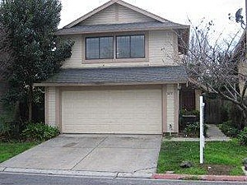
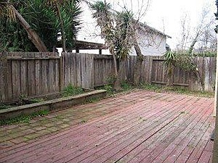
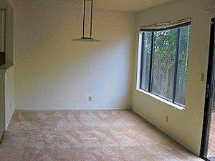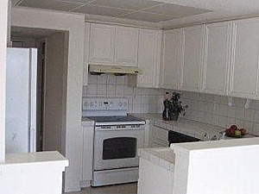
（8）地址：Address undisclosed San Jose CA 95131
房产编号：2136463873
价格：$477,800合334万人民币
类型：别墅
卧室：3
卫生间：2
面积：1,476 sq ft 合 137平米
花园面积：0 sqft
建筑年份：1986年
描述：This home is a Real Estate Owned (REO)/Post Foreclosure. Once a lender has foreclosed on a property it is soon put up for public auction. If bids fall short of the asking price the bank will buy back the home and attempt to sell it on the open market. However, lenders are not real estate agents, meaning that they will often accept offers significantly below market value!

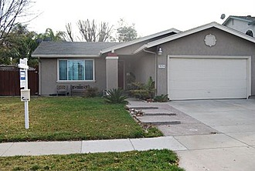
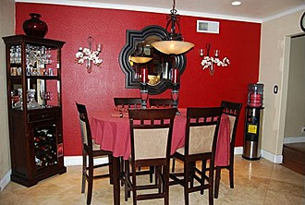
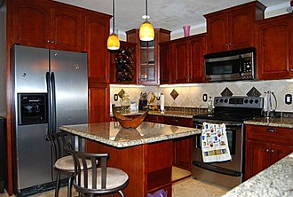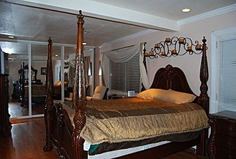
（9）地址：5374 Avenida Almendros San Jose CA 95123
房产编号：19707223
价格：$400,000合280万人民币
类型：别墅
卧室：3
卫生间：2
面积：1,340 sq ft 合 124平米
花园面积：6,300 sqft
估值：$437,500
2005年售价：$630,000
2009年财产税：$5,514
建筑年份：1971年
描述：Remodeled Home With A Great Layout In Move-In Ready Condition. Large Master Suite W Retreat & French Doors Leading To A Gorgeous Low Maintenance Back Yard. Gourmet Kitchen With Granite Counters & Cherry Cabinets, Laminate Floors Throughout, Newly Remodeled Bathrooms With Tiled Floors & Shower & Bath Stalls, Designer Lighting & Paint Throughout. Perfect For Outdoor BBQ's Under The Pergola W Stone Tiled Patio

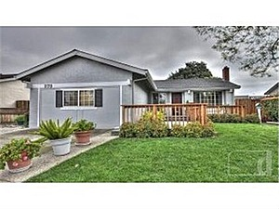
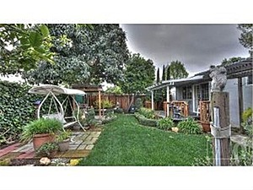
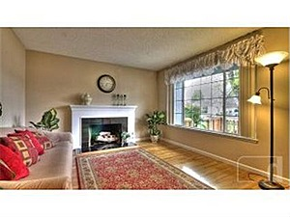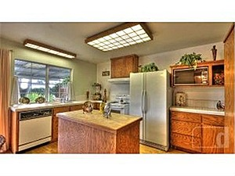
（10）地址：373 Avenida Manzanos San Jose CA 95123
房产编号：19707149
价格：$450,000合315万人民币
类型：别墅
卧室：3
卫生间：2
面积：1,134 sq ft 合 105平米
花园面积：6,299sqft
估值：$400,500
2009年财产税：$1,303
建筑年份：1971年
描述：Open Sunday 1:30-4:30! Wow! This home shows GREAT! Move right in,to many upgrades to list. Hardwood floors installed 4 years ago, dual pane windows, copper piping, Newer Central Heating, A/C, Roof and Gutters. Granite hearth around Gas fireplace. Flexible kitchen floor plan with removable island, tile counter tops. Charming backyard with deck and lush grass. Inspections completed

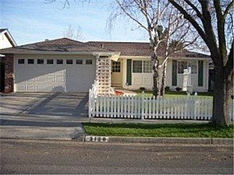
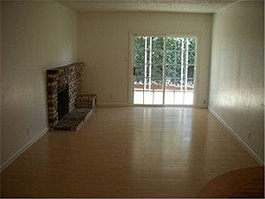
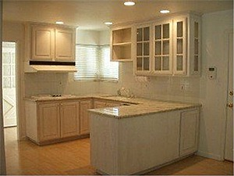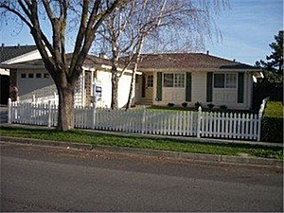
（11）地址：3120 Kermath Dr San Jose CA 95132
房产编号：19485203
价格：$449,000合314万人民币
类型：别墅
卧室：3
卫生间：2
面积：1,412 sq ft 合131 平米
花园面积：6,089 sqft
估值：$458,500
1989年售价：$148,500
2009年财产税：$3,405
建筑年份：1970年
描述：Wonderful Berryessa Hm in Northwood Park Area.Superb Curb Appeal.Super Clean and Bright Kitchen w/Granite Counters and Designer Cabinetry.Dining Area Features Built-In China Cabinet.Cozy FP in the Family Room.Spacious Living Room Overlooks Private Backyard. Master Suite w/Bath Featuring Granite Vanity and Designer Sink.Private Backyard with Covered Patio and Room to Play.Close to Shopping and Fwy Access.

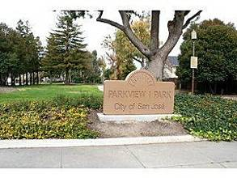
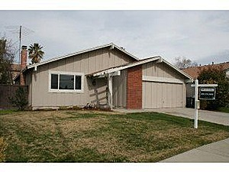
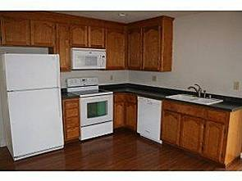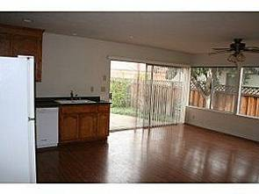
（12）地址：329 Bluefield Dr San Jose CA 95136
房产编号：19485203
价格：$489,000合342万人民币
类型：别墅
卧室：3
卫生间：2
面积：1,442sq ft 合 133平米
花园面积：5,662 sqft
估值：$463,500
2009年财产税：$1,505
建筑年份：1971年
描述：Clean, well maintained home in an established neighborhood. Large living/family room with wood burning fireplace focal point; really extra large dine-in kitchen with multiple large windows and lots of sunlight. Master bedroom has walk-in closet and separate bathroom. Back and side yard have a variety of fruit trees. Home has had many improvements to make it "move-in" ready - come by and see!

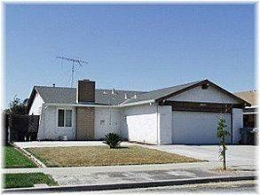
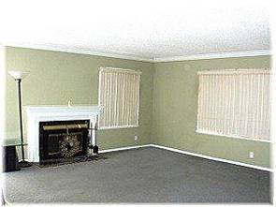
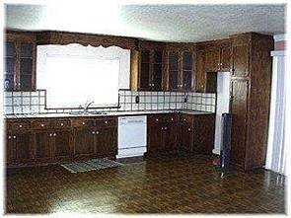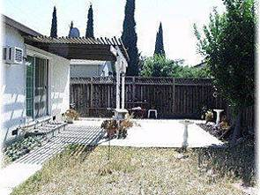
（13）地址：4185 Monet Cir San Jose CA 95136
房产编号：2135591870
价格：$424,500合297万人民币
类型：别墅
卧室：3
卫生间：2
面积：1793sq ft 合 166平米
花园面积：5,662 sqft
建筑年份：1972年
描述：Great Value, Bring Your Offer! Nice 3br 2ba floor plan. Dual-paned windows; composition roof; Newer Heating system, updated living room; large eat-in kitchen; fenced rear yard with patio. Neighborhood association with pool, Walk to nearby parks, public schools. Great opportunity! Brokered And Advertised By: Century 21-Alpha Listing Agent: Rick Vague

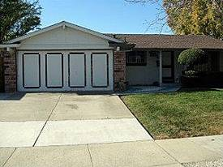
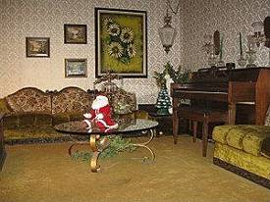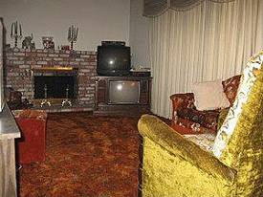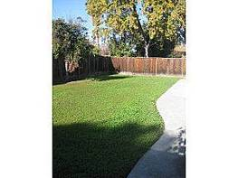
（14）地址：5903 Cabral Ave San Jose CA 95123
房产编号：19831090
价格：$488,000合341万人民币
类型：别墅
卧室：3
卫生间：2
面积：1,409 sq ft 合 130平米
花园面积：263,973,600 sqft
估值：$517,000
2009年财产税：$1,273
建筑年份：1972年
描述：PRICE REDUCED! This nice sized 3 bedrdoom, 2 bath home is in a wonderful location for your family! Close to the foothills, Almaden Lake Park, shopping, Schools, & Hwy, 85 & 87. The back yard is open & ready for your personal touch. Most of the furniture is being sold. Ask if you\'re interested.

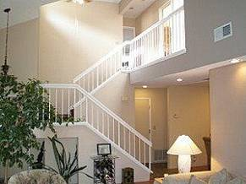
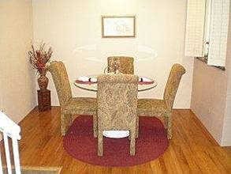
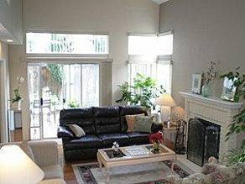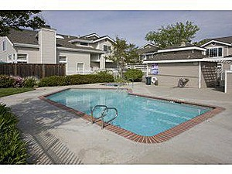
（15）地址：1470 Carrington Cir San Jose CA 95125
房产编号：2133984281
价格：$585,000 合409万人民币
类型：别墅
卧室：3
卫生间：2
面积：1,493 sq ft 合138 平米
花园面积：18,948,600 sqft
建筑年份：1987年
描述：WOW! Bring your Buyers-Outstanding Foxborough Crossing Townhome! Spacious Open Floor Plan (1,493sf)Refinished Hardwood Flrs, Granite Counter Tops, Soaring Vaulted Ceilings. 3 Large Bedrms and 2.5 remodeled Bathrms with Designer touches throughout. Enjoy the Sparkling Pool & Spa. Award Winning Schools: Presentation and Schallenberger. Steps to Restaurants & Starbucks. Regular Sale! A Must See!

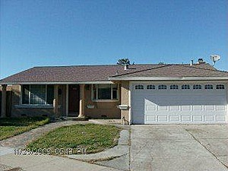
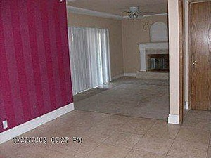
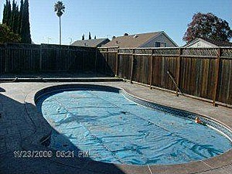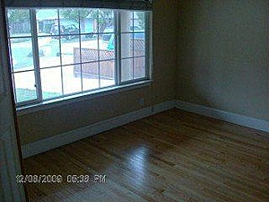
（16）地址：1635 Gypsy Place Ct San Jose CA 95121
房产编号：19806425
价格：$459,900 合321万人民币
类型：别墅
卧室：3
卫生间：2
面积：1,355 sq ft 合 125平米
花园面积：274,428,000 sqft
估值：$435,000
2005年售价：$685,000
2009年财产税：$6,151
建筑年份：1973年
描述：This bank owned home is looking for a new owner. Sparkling in ground pool on great cul-de-sac location. Easy access to Freeway. Dont miss this great opportunity.

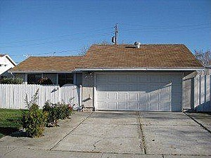
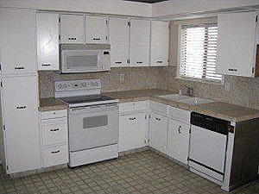
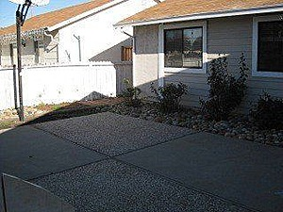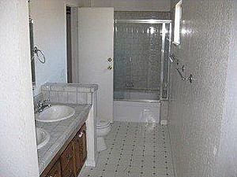
（17）地址：5802 Cahalan Ave San Jose CA 95123
房产编号：19819657
价格：$429,900 合300万人民币
类型：别墅
卧室：3
卫生间：2
面积：1,228 sq ft 合114 平米
花园面积：292,723,200 sqft
估值：$463,000
2009年售价：$441,000
2009年财产税：$6,526
建筑年份：1973年
描述：Property is going to Auction * Current List Price may differ than one on line so please CHECK the price.

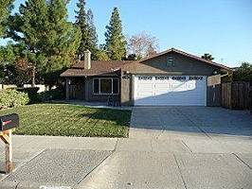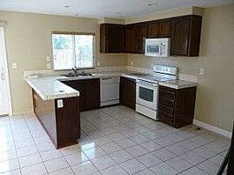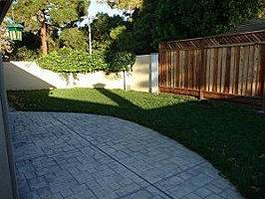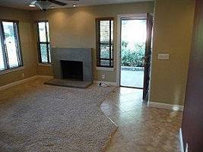
（18）地址：194 Avenida Espana San Jose CA 95139
房产编号：19842328
价格：$449,000 合314万人民币
类型：别墅
卧室：3
卫生间：2
面积：1,364 sq ft 合 126平米
花园面积：263,538,000 sqft
估值：$466,500
2009年售价：$469,000
2009年财产税：$5,477
建筑年份：1972年
描述：Would you like to remodel a kitchen? Everything else is done! Short sale opportunity in one of the best neighborhoods in San Jose. Experienced short sale agents with a perfect track record. All remodeling except for kitchen done recently with double pane windows, remodeled baths, exterior stucco, venetian plaster finish inside and much more.

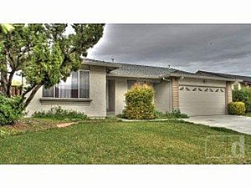
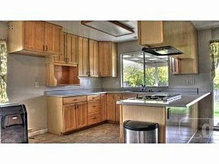
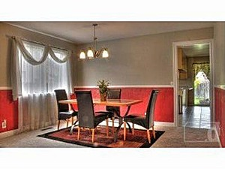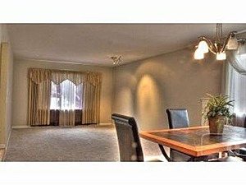
（19）地址：633 Shirecrest Ct San Jose CA 95123
房产编号：19709031
价格：$499,000 合349万人民币
类型：别墅
卧室：3
卫生间：2
面积：1,745 sq ft 合162 平米
花园面积：5,757sqft
估值：$509,500
2006年售价：$695,000
2009年财产税：$5,897
建筑年份：1977年
描述：Charming Blossom Valley home located in a quiet Cul-de-Sac. Open floor plan with inviting entry, separate dining room, and Spacious Master Suite with rear access. Dual closets/sinks in Master Suite.

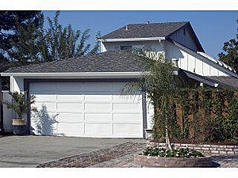
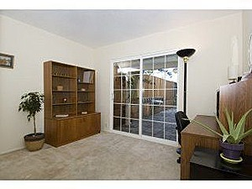
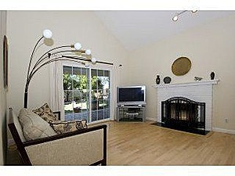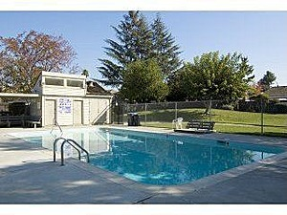
（20）地址：633 Shirecrest Ct San Jose CA 95123
房产编号：19695937
价格：$468,998 合328万人民币
类型：别墅
卧室：3
卫生间：2
面积：1,159 sq ft 合107 平米
花园面积：212,354,992 sqft
估值：$513,500
2006年售价：$575,000
2009年财产税：$7,199
建筑年份：1971年
描述：This is a must see property! located in one of nicest neighborhood in Cambrian. The floor plan is great with office downstairs/or bedroom with one full bath. Two bedrooms upstairs with one full bath. Big backyard with fruit trees and BBQ area.This is approved short sale!
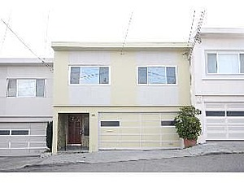
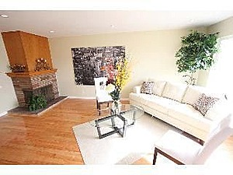
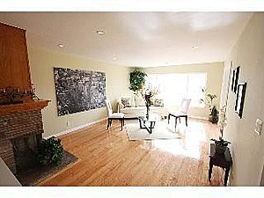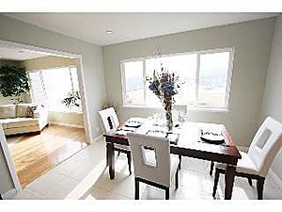
（21）地址：145 Ankeny St San Francisco CA 94134
房产编号：2133080839
价格：$598,000 合418万人民币
类型：公寓
卧室：3
卫生间：2
面积：1,362 sq ft 合126 平米
花园面积：0 sqft
建筑年份：1963年
描述：Beautifully Remodeled Gorgeous Home! Sweeping Views! Spacious 3 Bedrooms/2 Baths Hilltop Home. Large Living Room With Fireplace. Kitchen with Granite countertop & New Stainless Steel Applliances. Featuring all kinds of updates, such as Recessed Lighting, Double Pane Windows, Hardwood Floor. 2 Car Side by Side Garage. Convinent location, close to freeways, resturants, shops and MUNI #8 Busline.

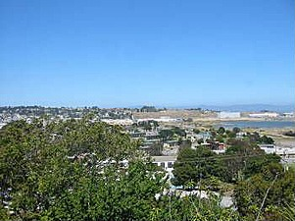
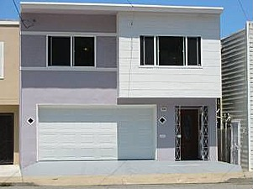
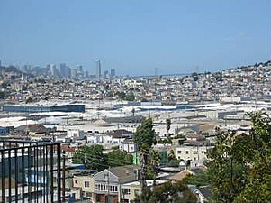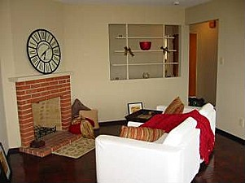
（22）地址：816 Jamestown Ave San Francisco CA 94124
房产编号：2138283078
价格：$499,000 合349万人民币
类型：公寓
卧室：3
卫生间：2
面积：1,204 sq ft 合111平米
花园面积：0 sqft
建筑年份：1962年
描述：Immaculate 3BR/2BA Bayview Heights home with views of Downtown SF. Semi-detached. New exterior and interior paint. Wood floors thoughout. Skylight in upstairs bathroom. Dual pane windows. New light fixtures. Kitchen w/built-in oven, cooktop. L-shaped LR/Dining room combo. Fireplace. Lot's of closet space and storage. 2 car garage. Large backyard w/cherry, plum, and alvocado trees. This is a must-see! O.H. Sunday 6/14 1:00 to 4:00pm.

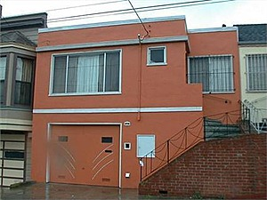
（23）地址：80 Scotia Ave San Francisco CA 94124
房产编号：15158388
价格：$549,000 合384万人民币
类型：公寓
卧室：3
卫生间：2
面积：1,500 sq ft 合139 平米
花园面积：0 sqft
估值：$581,500
2003年售价：$519,000
2009年财产税：$6,920
建筑年份：1962年
描述：Completely renovated home with refinished hardwood floors, featuring living room w/fireplace, newer kitchen w/eating area, 2 bedrooms one full bath in the main area. Downstairs 1 bedroom with a full bath, family room, den/office/storage room and one car garage. Also, there is big backyard with young trees.

