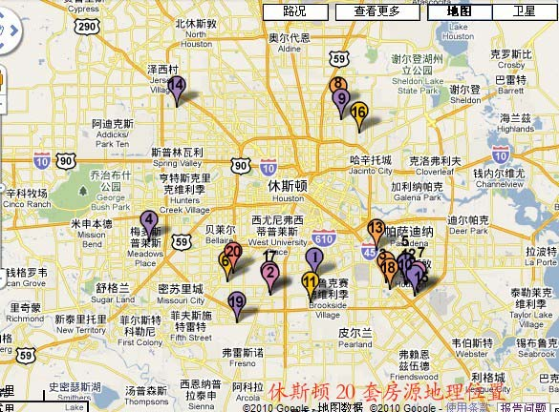

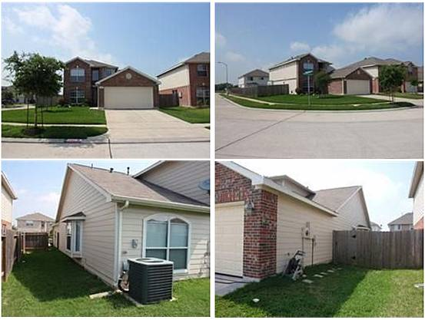

（1）地址：Houston, TX 77048
价格：$113,900 合 79.7万人民币
类型：别墅
卧室：4
卫生间：2.5
面积： 2,562 sq ft 合 238平方米
花园面积：6,549 sq ft
估值：$156,500
建筑年份：2006年
描述：Awesome new home under construction.Great corner lot !!! Hurry and you may be able to choose some selections for your new home. This home may qualify for City of Houston down payment assistance program. Call me for more information.

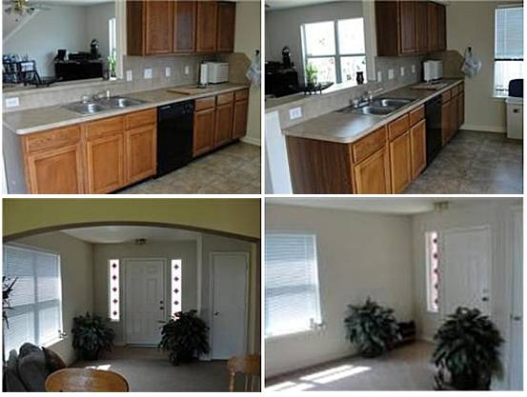

（2）地址： Houston, TX 77047
价格：$114,000 合 79.8万人民币
类型：别墅
卧室：4
卫生间：2.5
面积：1,902 sq ft 合 177平方米
花园面积：4,762 sq ft
估值：$119,500
建筑年份：2005年
描述：Charming well maintained 2.0 story home located in deed restricted area. This home features 4 bedrooms, 2.5 baths with 2 car garage. Large formal dining and living areas. Breakfast are, large master bedroom, kitchen with all appliances. Family room opens to the kitchen and breakfast areas. Nice sized backyard. All rooms sizes are approximate.

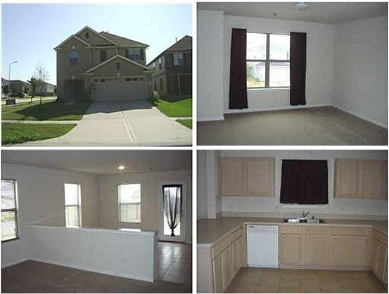

（3）地址：TX 77075
价格：$110,800 合77.5万人民币
类型：别墅
卧室：3
卫生间：2.5
面积：2,175 sq ft 合 202平方米
花园面积：4,198 sq ft
估值：$139,000
建筑年份：2006年
描述：This home is a Real Estate Owned (REO)/Post Foreclosure. Once a lender has foreclosed on a property it is soon put up for public auction. If bids fall short of the asking price the bank will buy back the home and attempt to sell it on the open market. However, lenders are not real estate agents, meaning that they will often accept offers significantly below market value!
.

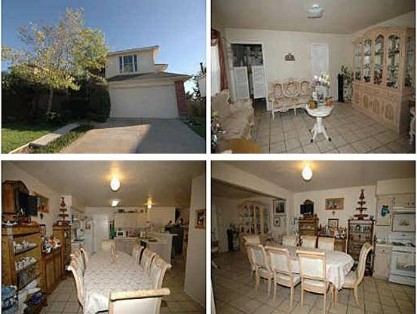

（4）地址：Houston, TX 77099
价格：$100,000合70万人民币
类型：别墅
卧室：4
卫生间：2.5
面积：2,270 sq ft 合211 平方米
花园面积：5,060 sq ft
估值：$116,500
建筑年份：1997年
描述：BEAUTIFUL HOME!! 4BED-2.1BTH-2CAR GARAGE.
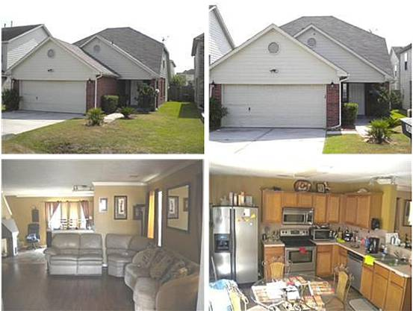

（5）地址：TX 77034
价格：$110，000合 77万人民币
类型：别墅
卧室：3
卫生间：2.5
面积：1,620 sq ft 合 99平方米
花园面积：3,520 sq ft
估值：$117,000
建筑年份：2002年
描述：VERY OPEN CONCEPT WITH CUSTOM PAINTED WALLS. RECENT LAMINATE FLOORS, RECENT TILE FLOORS. STAINLESS STEL APPLIANCES AND MUCH MORE. THIS IS A UNIQUE PLAN THAT IS PERFECT FOT THE FIRST TIME HOME BUYER OR INVESTOR LOOKING TO BUY. CONVIENTLY LOCATED CLOSE TO 45 SOUTH AND BELTWAY 8. THIS IS A MUST SEE PROPERTY. MOTIVATED SELLER SAYS BRING OFFERS.
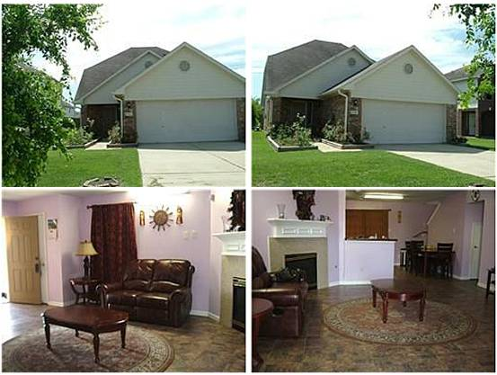

（6）地址：TX 77085
价格：$112,000合78.4万人民币
类型：别墅
卧室：3
卫生间：2.5
面积：1,590 sq ft 合148 平方米
花园面积：5,850 sq ft
估值：$115,000
建筑年份：2003年
描述：NICE HOUSE WITH 3 BEDROOM MASTER DOWN, 2 BEDROOMS UP AND SMALL ROOM BETWEEN THE 2 BEDROOMS USE FOR PRAYING.TILE IN THE FIRST FLOOR AND KITCHEN.BIG BACK YARD WITH COVER PATIO.
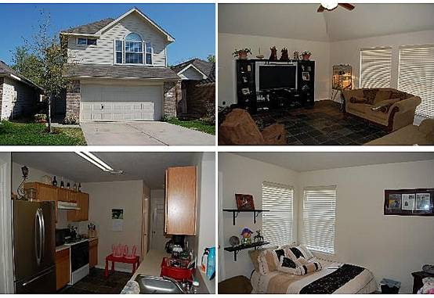

（7）地址：Houston, TX 77034
价格：$113,900 合 79.7万人民币
类型：别墅
卧室：3
卫生间：2.5
面积： 1,735 sq ft 合 161平方米
花园面积： 3,840 sq ft
估值：$135,000
建筑年份：2004年
描述：Two Story, 3 Bedroom, Spacious Living Room with Vaulted Ceiling, Formal Dining Room, Roomy Kitchen, Impressive Owner's Retreat with Vaulted Ceiling and Two Oversized Walk-In Closets, New Tile Flooring Downstairs.

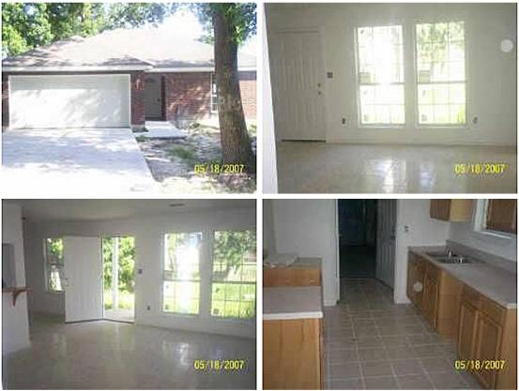
（8）地址：TX 77016
价格：$110,000 合77万人民币
类型：别墅
卧室：3
卫生间：2
面积：1,405 sq ft 合 130平方米
花园面积： 14,112 sq ft
建筑年份：2006年
描述：Cute home in older settled neighborhood. Great Neighbors, Great Locatio accessable to 59/610& Beltway. 15 min from medical center/15 min from downtown 15 to 20 mins from both airports. This home qualifies for up to 19,500 in downpayment assistance for qualified buyes.
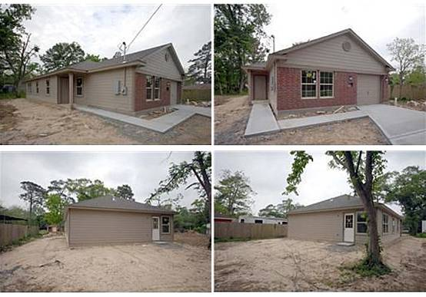
（9）地址：TX 77016
价格：$112,900 合79万人民币
类型：别墅
卧室：3
卫生间：2
面积：1,276 sq ft 合 118平方米
花园面积: 8,960 sq ft
建筑年份：2010年
描述：SOLAR SOLAR SOLAR to save you over $400/yr in utilities - Beautiful floor plan. Large eat-in kitchen w/granite countertops & 42'' cabs. Spacious master bedroom & master bath with garden tub & double vanity. In addition to Energy Star appliances the builder has gone above and beyond to ensure the energy efficiency of this home! Added Bonus - The builder is including a furniture package Living or Dining! There is a package to fit every taste - Contemporary to Traditional and everything in between!

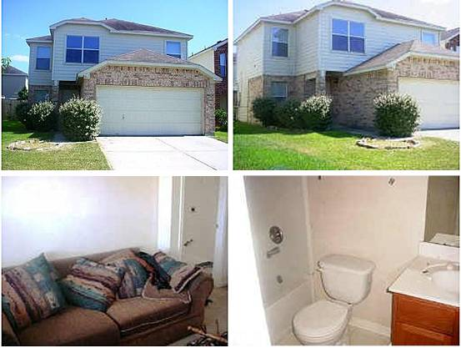
（10）地址：TX 77034
价格：$112,500 合78.7万人民币
类型：别墅
卧室：3
卫生间：2.5
面积：1,570sq ft 合 146平方米
花园面积：3,500sq ft
估值：$114,500
建筑年份：2002年
描述：A FANTASTIC DEAL FOR A BUYER OR AN INVESTOR SPECIAL DELIGHT IN PASADENA AREA! THIS IS A NEWER LOVELY UNIT THAT WILL HOME SOON! PRE-FORECLOSURE! A MUST SELL FAST AND THIS ONE IS PRICED BELOW HCAD AND PAY-OFF MARKET VALUE AND ALREADY APPROVED FOR SHORT SALE AT THE LIST PRICE. BRING ALL SERIOUS OFFERS WITH YOUR PRE-APPROVAL LETTER BECAUSE THE CURRENT LENDER APPROVED IS REQUIRED ON ALL OFFERS! THIS HOME NEEDS MINOR REPAIRS AND A LITTLE TENDER LOVING CARE. DON'T HESITATE, MAKE YOUR OFFER TODAY!

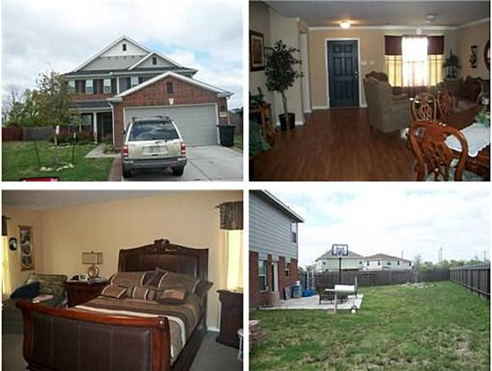

（11）地址： TX 77048
价格：$112,500 合78.7万人民币
类型：别墅
卧室：4
卫生间：2.5
面积：2,590sq ft 合 240平方米
花园面积：8,328sq ft
估值：$139,500
建筑年份：2006年
描述：Very Nice 4 Bedroom with large Master Bedroom on 1st Floor. Seller recently installed laminate flooring throughout the first floor. House is located in a cul de sac and has a super sized back yard.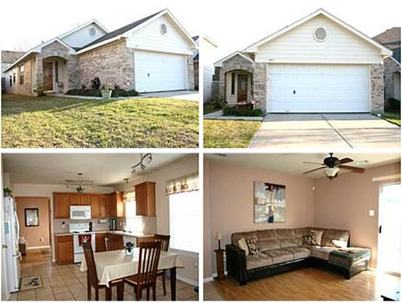

（12）地址：TX 77034
价格：$113,000 合79万人民币
类型：别墅
卧室：3
卫生间：3
面积：1,364sq ft 合 126平方米
花园面积：3,730 sq ft
建筑年份：2000年
描述：Good condition, updates include laminate flooring, title garden tub, near I-45 and 610.

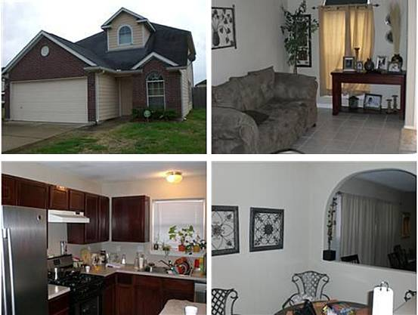
（13）地址：Houston, TX 77017
价格：$112,900 合79万人民币
类型：别墅
卧室：3
卫生间：2.5
面积：1,687 sq ft 合 156平方米
花园面积：2,888 sq ft
建筑年份：2002年
描述：BUYERS, HERES A HOME WITH EXTRA ROOM CAN BE USED AS A BEDROOM GIVING 2 BEDROOMS INCLUDING MASTER DOWNSTAIRS MAKING THIS A MODERN 4BEDROOM 2.5 BATHS HOME** OWNER HAS TILED THE LIVING,DINNING,KITCHEN AND BATHROOMS** KITCHEN ALSO HAS NICE BREAKFAST AREA**GAME ROOM UPSTAIRS** CONVENIENT LOCATION!! COME SEE TODAY!!

.

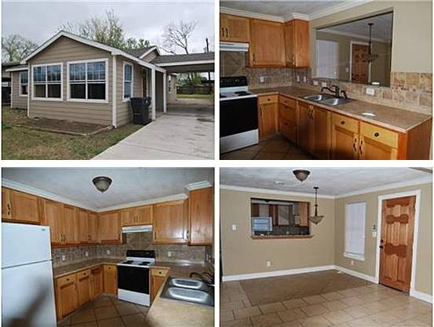

（14）地址：Houston, TX 77041
价格：$100,000 合70万人民币
类型：别墅
卧室：3
卫生间：2
面积：1,141 sq ft 合 88平方米
花园面积：7,000 sq ft
建筑年份：2009年
描述：Property was rebuilt in 2009 by seller. 3 Bedroom 2 bath home with a large backyard.

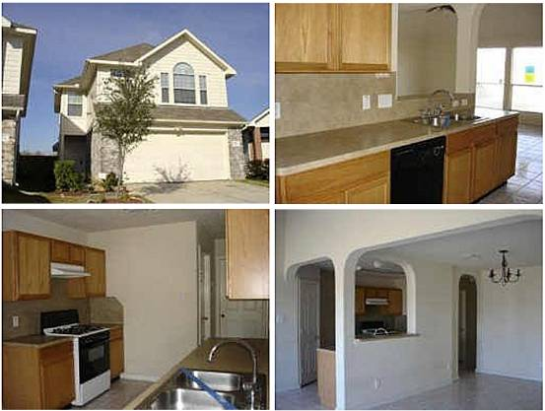

（15）地址：Houston, TX 77034
价格：$113,000 合79万人民币
类型：别墅
卧室：3
卫生间：2.5
面积：1,850 sq ft 合 172平方米
花园面积：3,902 sq ft
估值：$134,500
建筑年份：2006年
描述：Great Location. Easy Access To Beltway 8. House Is Only A Couple Of Years Old. 3 Bedrooms And 2.5 Baths. Tall Ceilings. Super Large Open Floor Plan With Arch Wall Accents. Large Master Suite With Walk-In Closts. Lots Of Windows And Great Natural Light In This Home. Home Has Tile And Carpet Flooring. Also Has Alarm System. Utility Room Inside. A Pretty Home. Come Take A Look. Being Sold ''As Is'' Per Seller.…

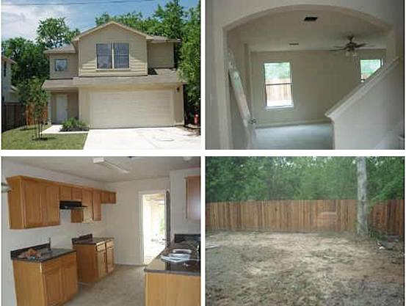
（16）地址：HOUSTON, TX 77028
价格：$100,000 合70万人民币
类型：别墅
卧室：3
卫生间：2.5
面积：1,500 sq ft 合 139平方米
花园面积：4,152 sq ft
建筑年份：2009年
描述：New Contruction. Two story 3/2.5/2. Elegant home. Architectural arches invite guest to foyer into spacious Family Room w/views to back yard with privacy fence, Breakfast and Kitchen featured w/medium oak colored cabinets amd classy black countertops. Retreat upstairs to Master Bedroom w /bathroom, hollywood lights, classy black vanity and 2 closets. Carpet, Vinyl flooring, gas range w /pven and mini blinds add a detailed touch. Remember, 30,000 Down Payment Assistance is offered through the city

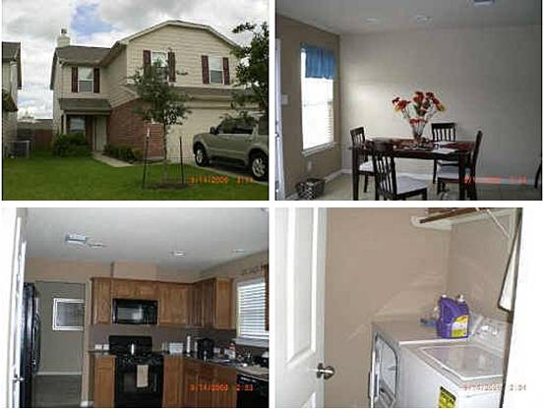

（17）地址：Houston, TX 77047
价格：$110,000 合77人民币
类型：别墅
卧室：4
卫生间：2.5
面积：2,125 sq ft 合 197平方米
花园面积：4,400 sq ft
估值：$127,000
建筑年份：2006年
描述：SHORT SALE. ALL OFFERS MUST BE APPROVED BY LENDER. MULTIPLE OFFERS. Home is approximately 3 years old. Minutes from the Medical Center & Downtown. No refrigerator,washer or dryer. Please use ALAMO TITLE, 2801 Post Oak, Blvd.

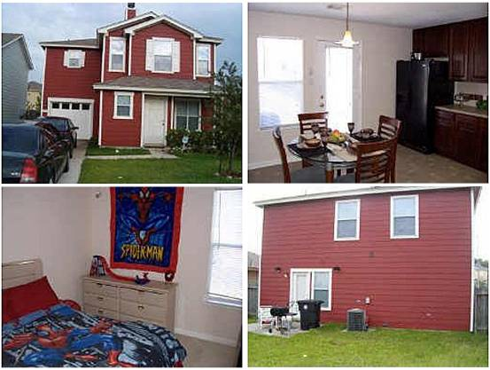

（18）地址：Houston, TX 77075
价格：$111,990 合78.4人民币
类型：别墅
卧室：3
卫生间：2.5
面积：1,440 sq ft 合 134平方米
花园面积：4,440 sq ft
估值：$127,000
建筑年份：2003年
描述：LOOK no further- Well-maintained home with loads of upgrades. Surround sound throughout, 42 inch cherry cabinets, full tile backsplash, and ceiling fans! Excellent curb appeal, almost new. Spacious backyard for family gatherings. PRICE REDUCED- Call now.
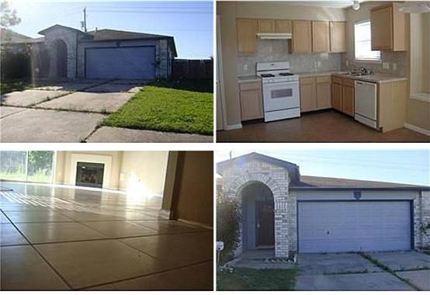

（19）地址： Houston, TX 77053
价格：$110,900 合77.6万人民币
类型：别墅
卧室：3
卫生间：2
面积：1,978 sq ft 合 184平方米
建筑年份：1999年
描述：Recently remodeled home in a good area. New fixtures, new appliances, new carpet and fresh paint throughout. Good size yard with concrete patio area and privacy fence. A must see! Call and make an appointment today!!

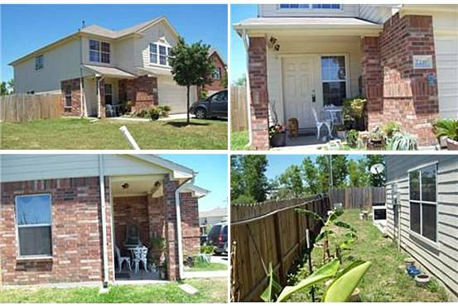

（20）地址：TX 77045
价格：$100,000 合70万人民币
类型：别墅
卧室：4
卫生间：2.5
面积：2,220 sq ft 合206平方米
花园面积：6,550 sq ft
估值：$147,500
建筑年份：2005年
描述：This 2220 square foot single family home has 4 bedrooms and 2.5 bathrooms. It is located at 5330 San Pablo Gardens Dr Houston, Texas. This home is in the Houston School District.

