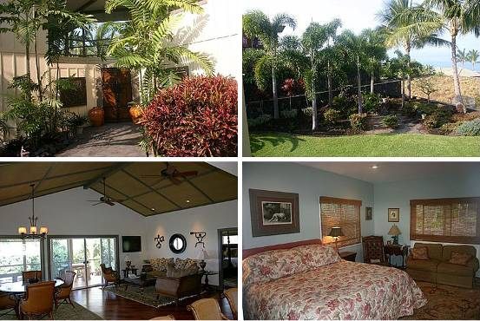
（1）地址：76-775 Io Pl Kailua Kona HI 96740
房产编号：60295439
价格：$1,269,000 合 888万人民币
类型：别墅
卧室：5
卫生间：4.5
面积：3,087 sq ft 合 287平方米
花园面积：22,476 sq ft
估值：$1,093,000
2005年售价：$979,000
2009年财产税：$3,575
建筑年份：2001年
描述：Rarely available residential "compound" just minutes away from downtown Kailua village. Accessed via a private road, this distinctive two- story home is perfect for multi-generational living, a large family or someone looking to maintain a professional home office. With over 3000 square feet of living area, and 1000 square feet of covered lanais this 5 bedroom, 4 1/2 bath house defines gracious island living at the perfect elevation of 750 feet. A world class outdoor kitchen is located on the first level adjacent to a covered, quartzite lanai which overlooks the 1/2 acre tropically landscaped, irrigated flat lawn. The palm tree laced grounds are perfect for the pet lover and there is plenty of room for a pool too! The main kitchen is located on the 2nd level and adjoins both the dining room and living room. Both kitchens are fully equipped with top of the line appliances and granite countertops. Three spacious, ensuite bedrooms are located on the 2nd level with an additional two bedrooms and adjoining bath on the first level. The attached garages can accommodate 5 vehicles and still provide abundant storage.
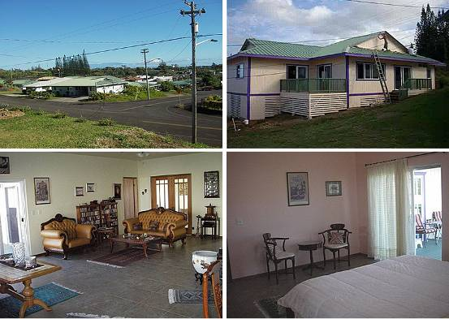
（2）地址：53-4056 Kolonahe St KAPAAU HI 96755
房产编号：561313
价格：$539,000 合 377万人民币
类型：别墅
卧室：4
卫生间：2.5
面积：1,924 sq ft 合 179平方米
估值：$366,500
2009年财产税：$1,456
花园面积：10,000 sq ft
建筑年份：2009年
描述：Home has many upgrades, to numerous to mention, all stainless steel appliances, many pull-out kitchen drawers, for example. All floors are covered with Italian Porcelain tiles. It is of post and pier construction, with extra strong support bracing. Home has nine foot ceilings throughout, with large windows, and several large sliding doors leading to large Lanais. Windows and sliding door facing afternoon sun are tinted. Includes all appliances, incl. washer and dryer. Home may be purchased fully furnished, at extra cost. Furniture is all almost new, and of very fine solid wood quality (Rosewood, etc.).

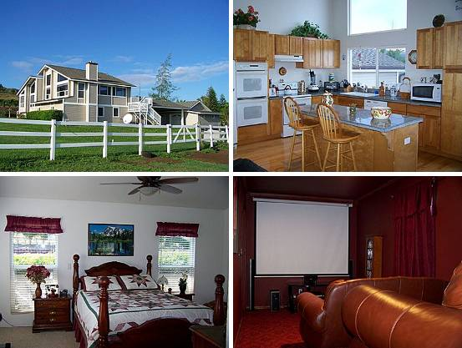
（3）地址：18 Hakuhee Way WAILUKU HI 96793
房产编号：88921924
价格：$1,500,000 合 1050万人民币
类型：别墅
卧室：4
卫生间：2.5
面积：2929 sq ft 合 272平方米
花园面积：134,861 sq ft
估值：$1,409,000
2000年售价：$235,000
2009年财产税：$2,298
建筑年份：2001年
描述：Gorgeous home with panoramic ocean views on over three acres. Split level open floor plan with high ceilings. Recently remodeled with an added game room and home theater. Many upgraded features that include tiger wood and oak floors. Plenty of space for horses with horse shelter and paddock area. There is also a four car garage and three attached storage rooms. Watch the morning sunrise from your living room and kitchen or unwind by the fish pond. All this conveniently located only 20 minutes from the central hub of Maui.

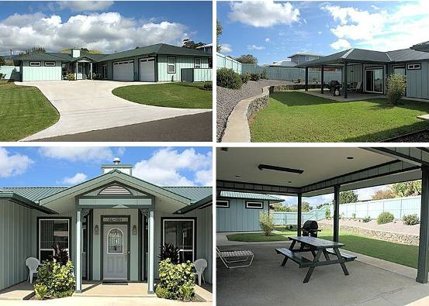
（4）地址：66-1324 Ahuli Cir HI 96743
房产编号：564200
价格：$626,000 合 437万人民币
类型：别墅
卧室：3
卫生间：3
面积：2,289 sq ft 合213 平方米
花园面积：12,388 sq ft
估值：$611,000
2003年售价：$110,000
2009年财产税：$2,488
建筑年份：2005年
描述：3BR/3BA (2289 sqft) built in 2006 with TONS of custom extras AND right in town! Etched-glass entry, high ceilings, privacy windows, fireplace, solid-wood cabinets throughout and surround sound....Nice kitchen with walk-in pantry, gas range, TV, eat-on counter?BIG inside laundry room HUGE 3-car garage with workbenches and lots of storage space?Immaculate landscaped yard, back is fenced with covered patio and all appliances, sound system and TVs stay! Additional details: All vinyl double pane UV rated Certainteed windows. Lifetime Warranty. Siding is cement fiber Hardi panel. All trim is composite. House is insulated and maintains a stable, comfortable temperature. 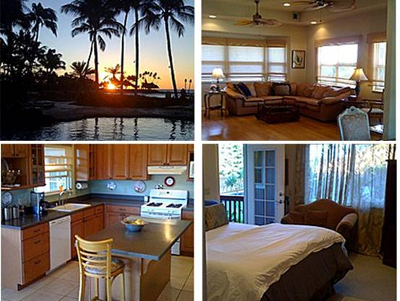
（5）地址：68-3787 Lua Kula St Waikoloa HI 96738
房产编号：564712
价格：$735,000合 514万人民币
类型：别墅
卧室：3
卫生间：2
面积：2,400 sq ft 合223 平方米
花园面积：10,681 sq ft
估值：$723,000
2004年售价：$565,000
2009年财产税：$2,256
建筑年份：2003年
描述：CUSTOM BUILT PLANTATION STYLE~ 3B 2B SALT WATER BLACK BOTTOM POOL W-WATER FEATURE ON THE COURSES SIGNATURE HOLE!!! -VAULTED CEILINGS 9 FT TO 14 FT ... SOFIT RECESSED LIGHTING THRU-OUT... BAMBOO ~ITALIAN PORCELAIN TILE FLOORING... DESIGNER LIGHTING FIXTURES AND WINDOW TREATMENTS...GAS RANGE W- ALL APPLIANCES ENERGY EFFICIENT STAYING ...BATHS LARGE WITH SELECTED GRANITE COUNTERTOPS. CORIAN IN GOURMET KITCHEN FEATURING DREAM VIEWS ! LARGE LANAIS FRONT AND BACK W- VIEWS OF KOHALA MTN RANGE AND MAUNA KEA ...PEEK OF OCEAN AND MAUI. ONE-OF-A-KIND PROPERTY...
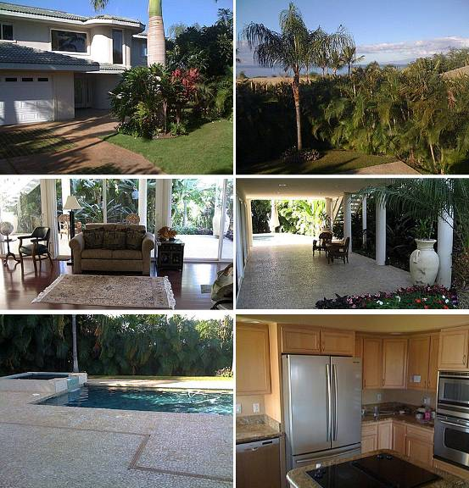
（6）地址：3356 W Lani Ikena Way Kihei HI 96753
房产编号：734751
价格：$2,395,000合 1676万人民币
类型：别墅
卧室：4
卫生间：3.5
面积：3,350 sq ft 合 311平方米
花园面积：11,608 sq ft
估值：$2,568,000
2003年售价：$1,180,000
2009年财产税：$2,909
建筑年份：2002年
描述：Magnificent Wailea Maui home. Currently rented, but available for either an investor/buyer or homeowner. Elevator in the home!
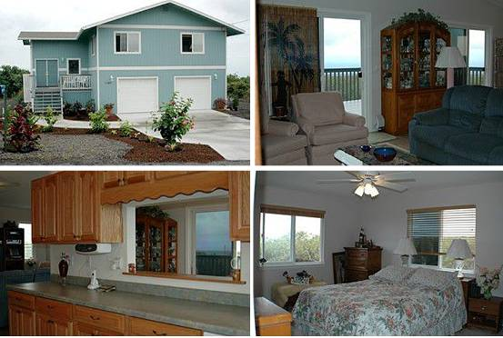
（7）地址：94 1432 Hiki Ku St. Naalehu HI 96772
房产编号：2146995342
价格：$395,000 合276 万人民币
类型：别墅
卧室：4
卫生间：3
面积：1,960 sq ft 合182 平方米
花园面积：14,000 sq ft
建筑年份：2005年
描述：Newly built 2005 4 BR/3BA, 2 BR/2BA up, 2 BR/1BA down. Downstairs rooms can be guest suites with private entry. Double door entry with large porch. Vaulted ceilings. Sliders open from LR/DR and 2 downstairs BRs. 4 spacious pantries. Master BR walk-in closet. UV coated sliders and windows. 900 SF lanai and porch space. Covered lower lanai. LP Smart Siding. Orchid/Greenhouse. Golf Course Community ($10.00 per round). Low Association Dues - $48.00 yr. County water. Oversized Garage 630 SF. Spacious Driveway parking for 4 cars - Plenty of on street parking too. Power saving 80 Gal solar voltaic hot water. Easy maintenance yard. Beaches and city/county parks are nearby Realtors 3% courtesy.

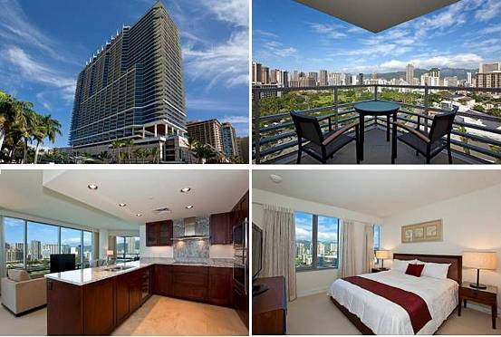
（8）地址：223 Saratoga Rd Honolulu HI 96815
房产编号：2134134950
价格：$1,868,900 合 1308万人民币
类型：公寓
卧室：2
卫生间：2
面积：1,139 sq ft 合 106平方米
建筑年份：2009年
描述：TRUMP WAIKIKI.

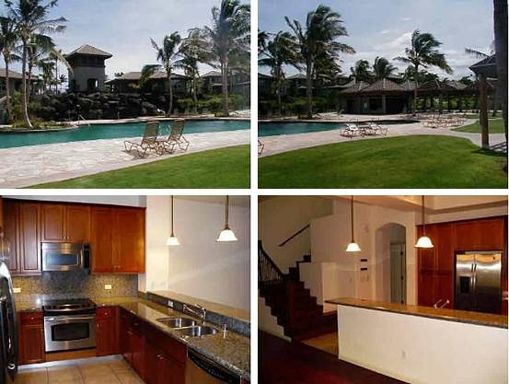
（9）地址：68 N Kaniku Dr APT 1804 Kamuela HI 96743
房产编号：2132448281
价格：$499,000 合349 万人民币
类型：别墅
卧室：2
卫生间：2.5
面积：1,646 sq ft 合 153平方米
建筑年份：2005年
描述：Great interior location in Building 18 with lanai views to the pool. This gated community of town homes is located along the 4th and 12th fairways of the Championship North Course at Mauna Lani Resort. Features of this golf course frontage town home include: Ohia post covered lanai with gas grill Tile and hardwood flooringGranite counter topsVaulted ceilingsRecessed lightingAir-conditioningOne-car attached garageLarge master bath with soaking tub and showerBreakfast barInterior laundry areaAmple storage.

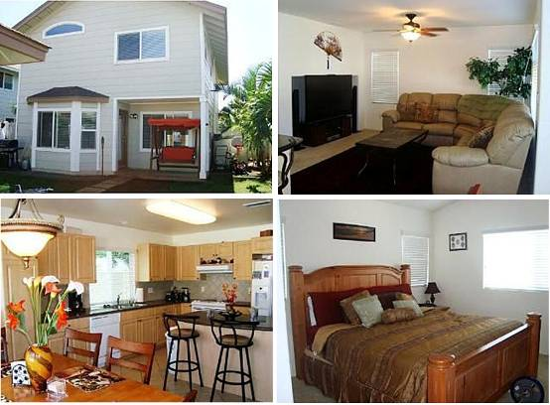
（10）地址：91 Kai Loli St Ewa Beach HI 96706
房产编号：2132448285
价格：$575,000 合402 万人民币
类型：别墅
卧室：4
卫生间：3
面积：1,737 sq ft 合 161平方米
建筑年份：2006年
描述：Beautiful 4 bdrm 3 bath spacious home with tropical landscaping backyard. Close to park in wonderful Ocean Point neighborhood.

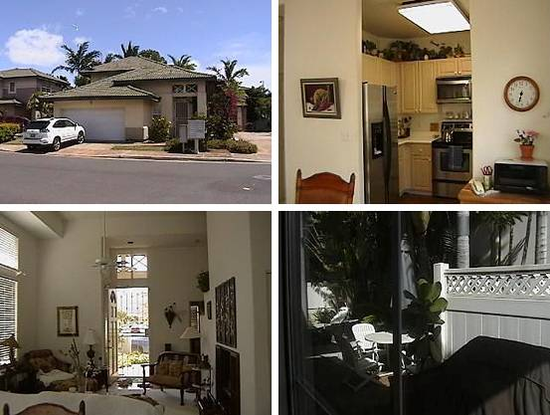
（11）地址：91 Maulihiwa St Kapolei HI 96707
房产编号：2132448309
价格：$529,000 合 370万人民币
类型：别墅
卧室：3
卫生间：2.5
面积：1,320 sq ft 合 122平方米
建筑年份：1994年
描述：

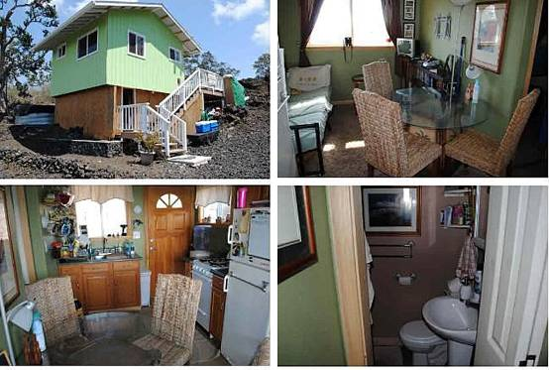
（12）地址：Catamaran Ln Ocean View HI 96737
房产编号：2132448316
价格：$44,999 合 31万人民币
类型：别墅
卧室：1
卫生间：1
面积：256 sq ft 合 24平方米
建筑年份：2009年
描述：Cute and Clean 16X16 1 bedroom 1 bath with built in bed. Oak kitchen cabinets and outside deck area. Nice comfortable living while you build you dream home. Bulldozed and ready to build.

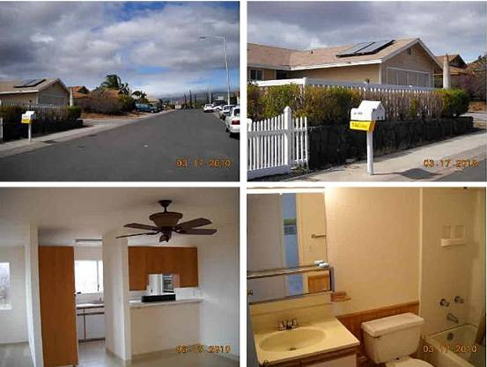
（13）地址：68 Kupunahine St Waikoloa HI 96738
房产编号：2132448322
价格：$239,900 合 168万人民币
类型：别墅
卧室：3
卫生间：2
面积：2235 sq ft 合 208平方米
建筑年份：1992年
描述：PANIOLO ESTATES Three bedroom and two bath with new carpet and interior paint! Smooth top counters in kitchen, and a huge Fully fenced yard, that's a ''blank slate'' for landscaping, gardening and playing. Property has ocean and mountain views.Within one block of Waikoloa Public Elementary School.

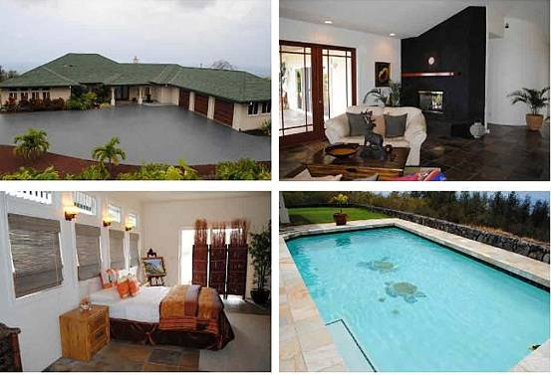
（14）地址：72 Makalei Dr Kailua Kona HI 96740
房产编号：2132448325
价格：$1,665,000 合 1165万人民币
类型：别墅
卧室：4
卫生间：4
面积：3,410 sq ft 合317 平方米
建筑年份：2004年
描述：Unbelievable Custom Makalei Home in newly gated upscale community with sweeping 180 degree coast line views of Kailua Kona. Enjoy the large covered lanai and the salt-water pool!*Expansive open living room with a gas fireplace. *Custom pocket sliders open onto covered lanai with cedar sofiting, slate tiling, and wet bar. *Gourmet kitchen with Alder custom cabinets*Viking Professional gas range*Viking Professional Refrigerator*Kitchen Aid Convection Microwave/Wall Oven, *Island cook top*Dishwasher *Compactor *Built in Wine CoolerSlate flooring throughout the whole house and the bath rooms. *Beautiful Master Bedroom on north side of house with his and hers walk in closet and recessed lighting to enjoy in the evening. *Master bath has nice walk-in showerjetted Jacuzzi tub surrounded by glass block.*Enjoy the sauna that seats five w/two entrances *Central vacuum*Maytag Neptune washer and dryer *Built in hutch in dinning area *Three car garage. 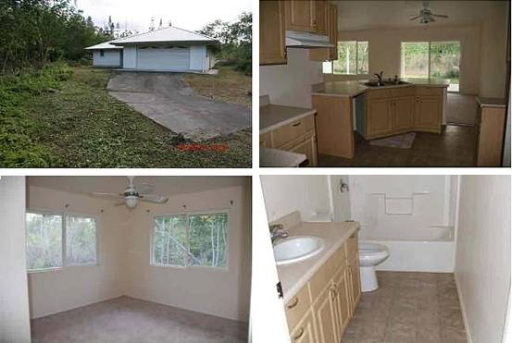
（15）地址：15 29th St Keaau HI 96749
房产编号：2132448326
价格：$219,900合 154万人民币
类型：别墅
卧室：3
卫生间：2
面积：1,476 sq ft 合137 平方米
2009年财产税：$2,256
建筑年份：2005年
描述：Spacious home / great location! Recent Renovations. This convenient floor plan assures privacy and space. The Master Bedroom located at the other side of the home from the kitchen and other bedrooms. Master bedroom has walk-in closet, and dual vanities. The Kitchen has ample counter and cabinet space, maple cabinets. A Pass through the kitchen into the utility room enables you to do your laundry right in the house. Laundry area has utility closet, additional cabinets, hookup for utility sink, and counter space for sorting laundry. Large two-car garage to accomodate your vehicles, tools and toys with huge storage closet with sliding doors and separate side entry to home in addition to the automatic garage door.
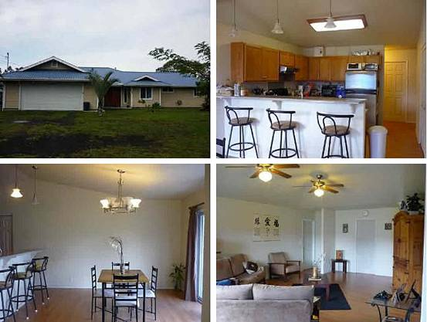
（16）地址：15 26th Ave Keaau HI 96749
房产编号：2132448368
价格：$199,000合 139万人民币
类型：别墅
卧室：3
卫生间：3
面积：1,998 sq ft 合 185平方米
建筑年份：2003年
描述：
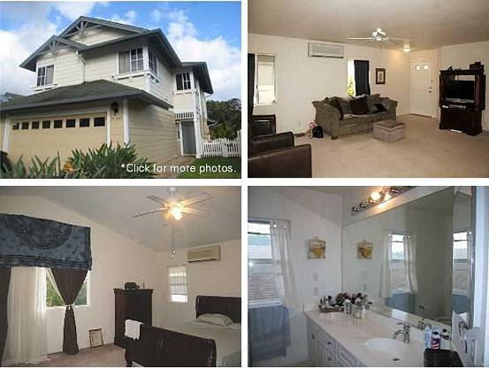
（17）地址：94 Pumaia Pl Waipahu HI 96797
房产编号：2132448375
价格：$599,000 合419 万人民币
类型：别墅
卧室：3
卫生间：2.5
面积：4,161 sq ft 合387 平方米
建筑年份：2000年
描述：Celebration's largest model. 2 end bedrooms converted to one large one. Enjoy 4 split systems A/Cs with attic & ceiling insulation. Perimeter location with covered lanai & two car driveway. Fully fenced yard & landscaped. Includes security system & security lights. Upgraded with Corian kitchen counter tops & smooth top range. Wood laminate in kitchen, dining and entry.

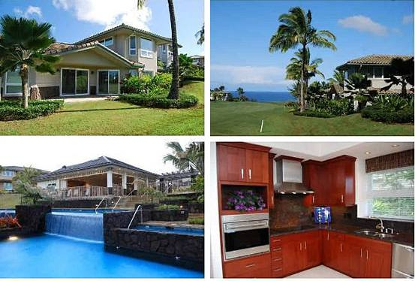
（18）地址：4100 Queen Emmas Dr Princeville HI 96722
房产编号：2132940306
价格：$1,649,000 合 1154万人民币
类型：别墅
卧室：3
卫生间：3.5
面积：2,476 sq ft 合 230平方米
建筑年份：2007年
描述：Situated on the 8th Fairway of the Prince course (the #1 rated course in Hawaii), this stunning new home at Ka'iulani features numerous luxurious amenities.The Layout E is a Fairway Home with three bedrooms (two are masters), three bathrooms. -Never occupied -Designed by Honolulu firm, Architects Hawaii, LTD. and won the 2009 Architectural Design Award!-11? high living room-2,479 livable sq ft -3,328 total sq ft-Assisted cooling (AC)-Two-car garage -Pre-plumbed for LP gas cooktop, etc.-Sub-Zero and Wolf built-in stainless-steel appliances: refrigerator, electric wall oven, electric cook top-Fisher Paykell dishwasher-Maytag Neptune Super Stacker washer/dryer -Custom Aristocratic cabinets with slab granite countertops throughout -Kohler and Grohe plumbing-7? solid core doors -Contemporary window coveringsAdditional amenities include three heated pools, spa and two barbecue pavilions, walking paths

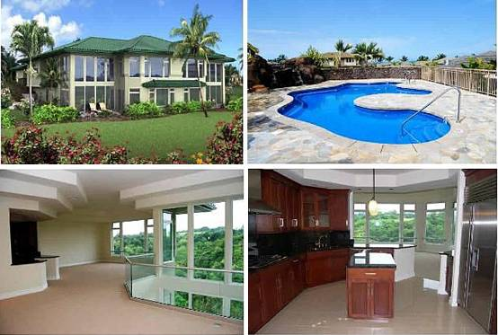
（19）地址：4100 Queen Emmas Dr APT 11 Princeville HI 96722
房产编号：2138499739
价格：$1,995,000 合1396 万人民币
类型：别墅
卧室：3
卫生间：3.5
面积：2,873 sq ft 合 267平方米
建筑年份：2007年
描述：Ka`iulani of Princeville #11, Layout A, is a Valley Home with 3 bedrooms (2 are masters), 3-1/2 bathrooms.- Brand New (Completed 2008). -- Assisted cooling (AC).- Two-car garage w/ sink.- Sub-Zero and Wolf built-in stainless-steel appliances: refrigerator, electric wall oven and cook top.- Custom cabinetry with slab granite counters through-out.- Kohler & Grohe plumbing.Ka`iulani of Princeville is located on an 18-acre parcel in Queen Emma's Bluffs - considered the most prestigious area of Princeville, Kauai. The land is on a peninsular bluff.Ka`iulani of Princeville is a low-density luxury residential community consisting of 77 attached homes. The basic design concept includes upscale design, finishes, and amenities for second-home buyers with ''above-the-ordinary'' requirements.Common amenities include 3 heated pools, spa, 2 bbq-area pavilions, 1/2 mile lighted walking path, resident manager
.

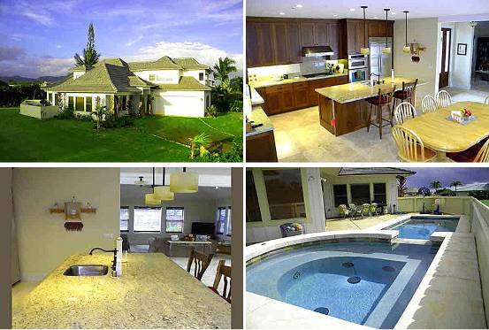
（20）地址：5345 Pau A Laka St KOLOA HI 96756
房产编号：722730
价格：$1,725,000 合1207 万人民币
类型：别墅
卧室：3
卫生间：4
面积：3,229 sq ft 合 300平方米
估值：$1,778,000
2005年售价：$470,000
2009年财产税：$6,568
建筑年份：2009年
描述：This is the newest home in Poipus Kiahuna Golf Village. Situated on an interior lot with views of the ocean and fairways to the south and dramatic mountain vistas to the North. This 2-story Plantation Style home features two master suites (one on each floor)and a private guest suite. There are four full baths, an outdoor shower off of the master bath and a large private media room. There is a beautiful pool and spa. Nicely landscaped. Home is built with high-station quality for the discerning and sophisticated buyer. Travertine tile floors; granite counter tops in the kitchen and baths; central vacuum system; Split-system air conditioning; Audio system distributed throughout the house; Top of the line gas appliances; on-demand gas water heater; Cement tile with baked finish roofing tiles; Anderson windows; Custom landscaping with sprinkler system.

