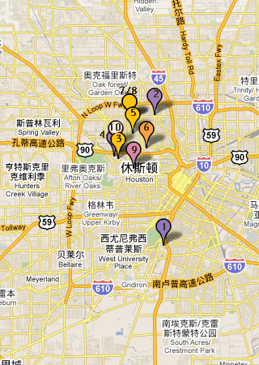

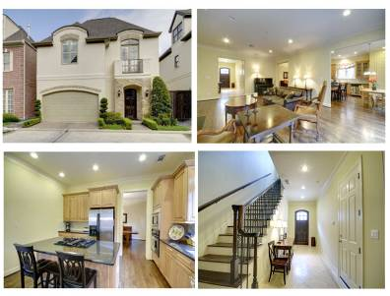

- 地址： Houston, TX 77021
价格：$499,000 合 万人民币
类型：别墅
卧室：3
卫生间：4.5
面积：3,250 sqft合301.9平方米
建筑年代：2005
描述：Stylish stone/stucco Lovett patio home in gated community near Med Ctr. First floor living, bedrooms on 2nd floor, bonus room w bath on 3rd. High quality finishes & flooring throughout. Island kitchen w granite counters & stainless steel appliances - refrigerator included. Huge master suite w spa tub & 2 large closets. 3rd floor great for study, gameroom or guest. High ceilings, large rooms, lots of storage, private patio. On a cul-de-sac in center of community

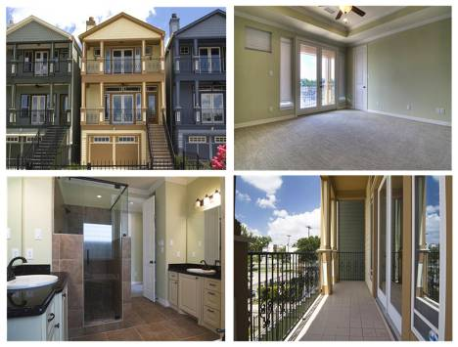

(2)
地址： Houston, TX 77009
价格：$339,000合 万人民币
类型：别墅
卧室：3
卫生间：2.5
面积：2651 sqft合246.3平方米
建筑年代：2008
描述：Great Victorian style New Construction Homes in the Heights. Quality extensive trim work, hardwoods and tile throughout. Nice floor plan with Living, Dining, Powder Room and Kitchen on second floor. Two bedrooms, 2 baths on third floor including Master Bedroom. One Bedroom and one Bath on first floor. Two car attached garage and Backyard Green Space. Easy access to 610 and HWY45. Close to Heights 19th Shopping and Restaurants, and The Farmer's Market.

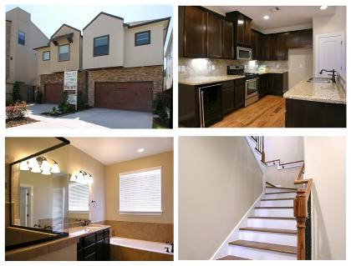

(3)
地址： Houston, TX 77007
价格：319,900 合 万人民币
类型：别墅
卧室：3
卫生间：2.5
面积：1806sqft合167.8 平方米
建筑年代：2010-
描述：This 1806 square foot single family home has 3 bedrooms and 2.5 bathrooms. This home is in the Houston School District.

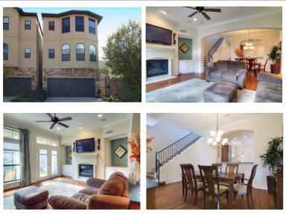

(4)
地址： Houston, TX 77007
价格：$469,000 合 万人民币
类型：别墅
卧室：4
卫生间：3.5
面积：2831sqft合263平方米
建筑年代：2007
描述：Have your own back yard in Rice Military! Gorgeous home - exceptional details; 4 bedrooms, 3.5 baths. Living, dining, kitchen, bkfst on first floor with all bedrooms up. Gated entry; high ceilings; gleaming hardwoods down; spacious open living and dining. Big island kitchen w/ granite, stainless appl, double oven, wine fridge. Huge master suite plus 2 bedrooms/bath on second floor. Third floor 4th bedroom, bath; great for home gym, guest suite or office. Private driveway for extra guest parking.

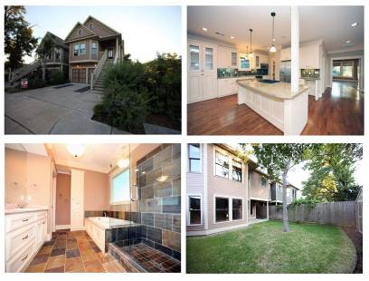

(5)
地址： Houston, TX 77008
价格：$445,000 合 万人民币
类型：别墅
卧室：3
卫生间：3
面积：2293 sqft合213 平方米
建筑年代：2005
描述：This 2293 square foot single family home has 3 bedrooms and 2.5 bathrooms.. This home is in the Houston School District.

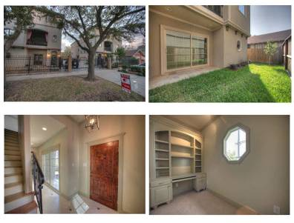

(6)

地址： BHouston, TX 77007
价格：$429,000 合 万人民币
类型：别墅
卧室：3
卫生间：3.5
面积：2500sqft合232平方米
建筑年代：2010
描述：This 2500 square foot single family home has 3 bedrooms and 3.5 bathrooms.. This home is in the Houston School District.

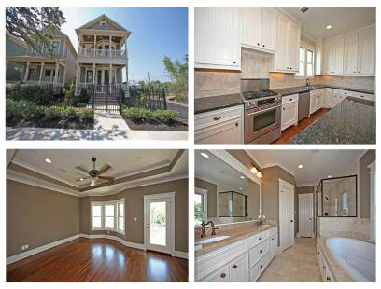

(7)
地址： Houston, TX 77008
价格：$419,000 合 万人民币
类型：别墅
卧室：3
卫生间：2.5
面积：2201sqft合204.5平方米
建筑年代：2010
描述：Timeless style and superior construction are evident throughout this recently completed Heights area home by Bastian Builders. Detailed trim moldings, reclaimed hardwoods, extensive recessed lighting, high ceilings, generously sized formals & chefs kitchen w/granite, SS appliances, wine rack & large island. Master retreat w/access to 2nd floor balcony, coffered ceiling & luxurious bath w/whirlpool. 400 sq.ft. finished Garage Apartment w/bath, alarm & sound pre-wire. Click on docs for more info

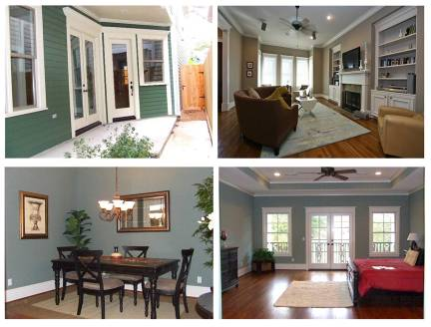

(8)
地址： Houston, TX 77008
价格：$399,000 合 万人民币
类型：别墅
卧室：3
卫生间：2.5
面积：2251 sqft合209平方米
建筑年代：2010
描述：New construction in the Heights by Bastian Builders with a pool! Home will offer the quality finishes and attention to detail that Bastian is known for; extensive trim moldings, reclaimed hardwood floors, extensive recessed lighting, the use of natural stone in all wet areas and a well appointed kitchen with a SS appliance package, built-in wine rack & large center island w/sink. 1st floor study, alarm pre-wire and large backyard with a pool!

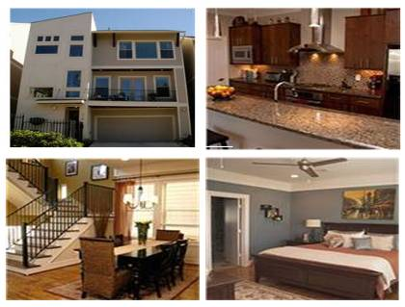

(9)
地址： Houston, TX 77007
价格：$384,900合 人民币
类型：别墅
卧室：3
卫生间：3.5
面积：2150sqft合199.7平方米
建筑年代：2008
描述：Beautiful Tricon home in the heart of Rice Military - close enough to walk to Washington, far enough to avoid the noise & traffic. Gourmet kitchen with Jenn air stainless appliances, custom cabinets. Beautiful crown molding, 10' ceilings, hardwood floors. 2nd floor living with patio.Gorgeous stone shower surrounds & floors in baths. One bdrm 1st flr, 2 on 3rd flr. Close to downtown, Memorial. Faux wood blinds, granite countertops, glass tile trim. Gigantic master closet. Energy star rated.…

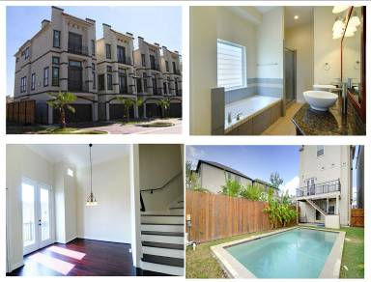

(10)

地址： Houston, TX 77007
价格：$360,000 合 万人民币
类型：别墅
卧室：3
卫生间：3.5
面积：2420sqft合224.8平方米
建筑年代：2007
描述：Modern & Meditteranean stucco home w lg backyard, 12x24 POOL & 3 balconies. Bdrm 2 down - private bath, covered patio. Open living on 2nd level w handscraped Brazilian Cherry hardwood flr (incl all stairs), hi clgs. Island kitchen w granite counters, stained cabinets, brkfst area. Spa tubs Master/Bdrm 3, granite all baths, brushed nickel hdwr/fixtures, dbl crown mldg, clg fans. Stamped driveway & stained oak garage door.…

